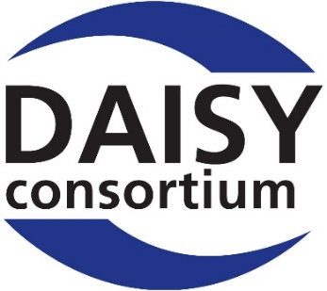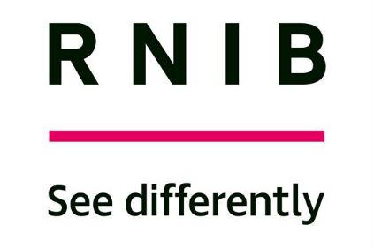

DAISY Music Braille Project:
Notes of the Second Round Table Meeting, 31 October 2018,

at RNIB, London

Contents

Introduction 2
Executive Summary 4
Participants 8
In the room 8
Online 9
Welcome and introductions (15 mins) 9
Proposed Next Steps: updates with brief questions (90 mins) 10
1. Identify and prioritize immediate fixes required in current tools to share with developers (15 minutes) 10
2. Learn from trial of DZB tools currently underway at Dedicon (10 minutes) 10
3. Establish our requirements for MusicXML (or MNX) improvements with W3C (15 minutes) 11
4. Establish and trial a MusicXML specification for publishers (5 minutes) 13
5. Establish how MusicXML and BMML can be used together, and how/if we could convert between them (10 minutes) 14
6. Establish and trial the best file formats and minimum metadata needed for effective international music braille file retrieval (15 minutes) 15
7. Trial outsourcing music braille production to an off-shore agency (10 minutes) 19
8. Review specification documents for existing conversion tools, including Haipeng Hu’s proposals, to prepare for the requirements capture process (10 minutes) 20
Update from: Bill McCann, GoodFeel/Dancing Dots 22
9. Establish ways to document/harmonise country codes and layouts to facilitate file sharing and conversion, with ICEB (English Council on English Braille) and World Braille Council (5 minutes) 23
10. Discuss with World Braille Council their planned Music Braille Summit in Paris 25-26 April 2019 (10 minutes) 23
Music Braille Tool Specification Presentation and Discussion (90 minutes) 24
Haipeng Hu - a music braille tool specification framework 25
Questions and discussion 27
Summing up (Arne) 29
A Roadmap for the Development of Music Braille Tools (30 minutes) 30
Open discussion and next steps (90 minutes) 32
Close 35
Annex – Teaching and Learning of Music Braille 35

Introduction

A second discussion and planning session on the future direction of standards and tools for the production and sharing of music braille files, following on from the first Round Table Meeting in Leipzig in June.

This meeting was to review progress on work areas identified after the Leipzig meeting, and to plan for longer-term initiatives. The goal of this meeting was to agree concrete next steps and to obtain commitments for contributions of expertise and the possibility of funding to secure future work.
Chaired by: Arne Kyrkjebø and Sarah Morley Wilkins.

Project documents: All reports and project documentation, including notes and presentations from this and previous meetings can be found at www.daisy.org/project/daisy-music-braille.

Recording: Eivind Haugen
Notes: Sarah Morley Wilkins and Kari Rudjord

Executive Summary

This second Round Table meeting was well-attended with nearly 40 in the room and 12 online, representing some of the major blindness agencies world-wide, as well as some of the producers of the current music braille conversion tools and other sector specialists, coming from: Australia, Canada, China, Europe, India, Korea, New Zealand and USA.

Progress Updates
We had updates on progress on our 10 ‘Next Steps’ taken after our June Leipzig meeting:
- Improve existing tools. A range of materials are being tested with three main tools (GoodFeel, Hodder and BrailleMUSE), with outcomes being shared with the developers for feedback.
- Learn from a trial of DZB’s Hodder tool at Dedicon. The trial started in September, getting positive results so far having tested around half their range of materials. The two organisations will consider the experience in early 2019 and considerations will be made as to whether DZB would consider extending access to other agencies.
- Influence MusicXML/MNX. We can start to influence the development of MNX – the successor code to MusicXML - with the W3C Music Notation Community Group, by submitting examples of where MusicXML does not provide sufficient information for our conversion tools. This should make music braille conversion in the future more easily automated and more reliable.
- Establish a MusicXML standard for publishers. Asking Music Publishers to give us better MusicXML files isn’t likely to be successful. We could try to influence the MusicXML output of e.g. Sibelius/Finale, but the barriers could be numerous. The onus is on our sector to know what kind of MusicXML we get, and what our tools do with it. Validator tools, and setting a standard could be helpful. Publisher charges/contracts were also discussed, and we agreed we would prepare a DAISY statement for publishers requesting free master files.
- Establish how MusicXML and BMML can work together. The use of BMML is still recommended by the Italian Library for the Blind, as it can contain all the information needed to convert into music braille, but needs further development.
- File formats and metadata for international file sharing. Bookshare, the ABC Global Book Service, and the NLS shared updates about their developing collections. Once CELA and RNIB catalogues have been ingested into Bookshare private label they will have 20-30,000 music braille titles available. The Global Book Service currently has 5,000 music braille titles available. Both shared their metadata fields. NLS are exploring how to make their files available outside the USA to other signatories of the Marrakesh Treaty.
- Trial outsourcing music braille production to an offshore agency. NLB is planning an initial trial to have MusicXML files marked up to a standard to suit our needs, to test with conversion tools. Later, they may also trial doing music braille conversions there too; to develop guidance and standards.
- Review specification documents to prepare for requirements capture. The specification framework proposed by Haipeng Hu is a good starting point for us to consider what an improved tool could look like, or what improvements could be made to existing tools. We need to agree our requirements if we are to make a collaborative decision for change.
- Establish ways to document/harmonise country codes and layout for file sharing and conversion. For efficient automation it will be necessary to achieve a level of documentation and harmonisation not yet secured. Agencies will have to collaborate, but who will lead?
- Discuss with World Braille Council their planned Music Braille Summit in April. To avoid duplication of effort this has been cancelled, and activities will merge with this DAISY project. The Orbit braille display development project was described, and comparisons made with what might be needed for this sector. Agreeing the requirement and securing a process for collective decision-making would be vital.

Music Braille Tool Specification
This big agenda item was to hear about and discuss Haipeng Hu’s proposed conversion tool specification which brings together solutions to address current weaknesses in existing tools, either to build into a new tool, or to improve in current tools. As a blind musician, composer and transcriber he has experience of all the current tools and wanted to find a way to easily get good music braille produced.

Haipeng’s proposed technology provides several key features: it would be universal for various outputs and languages; it would provide accurate transcription using smart and flexible algorithms, and would use scores from various sources; it would have a project concept so allows for mixed format scores and file formats; it would have flexible and powerful formatting options for simple and even the most complex scores. It would have powerful editing and correction tools; user-serviceable functions capable of handling special cases; a copy-protection mechanism for publisher confidence; navigation and reading tools for blind musicians and learners to use themselves; three modes, free, standard, pro, to suit different user needs; and he suggested ways to improve the source file.

The discussion covered issues concerning: the benefits of following a mainstream code, and agreeing specifications which may narrow options available but would make automation easier; that music is a knowledge domain, like maths or chemistry, which does need the semantics to be conveyed appropriately; we’re never likely to get 100% automation; the range of user needs is quite diverse – perhaps one tool will not suit all; to use the specification to compare existing tools; to seek feedback from those developers about the future of their tools and businesses.

The morning session was summed up as needing to focus on: standards of the source file, assessing the conversion tools against the specification, exploring the business model of existing tools, and the need to agree our path and requirements to move forward – knowing this is likely to require compromise for the greater good.

A roadmap for the development of music braille
Bill McCann described how GoodFeel provides a range of features to support not only the production of music braille, but also for a blind user to write, edit, read and hear the notation, as well as displaying it on-screen, and on a braille display, illustrated by a variety of demonstrations. Bill has assessed GoodFeel against Haipeng’s specification, and believes it compares favourably against many of his criteria, whilst acknowledging areas for improvement. He supports the proposal to pool resources and agree requirements to achieve change in a cost-effective way, even though that is likely to mean a compromise for some.

Open discussion
This discussion session was wide-ranging and concerned the following major issues where we seemed to have broad agreement:
- Create a requirements document, and ask for feedback on this, and the specification (for the source file, and the conversion tool), for everyone to review and respond.
- Give W3C examples of where MusicXML has failed us, to improve MNX, and ask for good examples of MusicXML 3.0 for us to test.
- Write a DAISY approach to publishers to encourage free file-sharing for the non-profit purposes of making braille music.
- Agree a ‘good’ MusicXML standard for our purposes, and devise a validator tool to check for minimum acceptable MusicXML, before a conversion is attempted.
- Devise smart error-checkers to automatically fix likely issues/make suggestions.
- An agency needs to take forward documenting music braille codes world-wide – with an ambition to harmonise as much as possible; but this is not DAISY’s responsibility.
- Help conversion tools improve their output when using a MusicXML file.
- Maintain a focus on music braille (rather than e.g. screen-reader access to notation)
- Conversion tools to be able to provide usable scores for new young musicians, as well as for proficient professionals.
- Secure a process for collective agreement and financial contributions.

Close
It was very encouraging to have so many people taking part and undertaking activities to move this all forward, as well as being part of the wider ‘interested parties’ community. Proposals for next steps will be shared, and offers of help were invited – we are the only ones who can make this change together. Looking forward to the next Round Table in Geneva around the DAISY board meeting dates of 27-29 May 2019 – date to be confirmed.

Annex
As the meeting did not have opportunity to discuss teaching and learning of music braille (although many are actively engaged in this important area) four relevant papers are included with the presentation folder which may help to link parties and ideas together.

Participants

In the room

First Name | Last  Name | Organisation | Country
James | Aitken | Lime Music Notation Editor | UK
Marc | Aufrant | AVH | France
Sara | Backström Lindeberg | Resource Center Vision, National Agency for Special Needs Education | Sweden
Roger | Beatty | CNIB | Canada
Giulio | Benincasa | Italian Library for the Blind | Italy
Peter | Bosher | SoundLinks | UK
James | Bowden | RNIB/UKAAF/ICEB | UK
Kevin | Carey | World Braille Council (WBC) | UK
Lia | Cariboni | SBS | Switzerland
Gianluca | Casalino | Italian Library for the Blind | Italy
Roger | Firman | UKAAF (UK Association for Accessible Formats) | UK
Ginny | Grant | BookShare/Benetech | USA
Stephan | Handels | Dedicon | Netherlands
Eivind | Haugen | NLB | Norway
Haipeng | Hu | BrailleOrch | China
Hannes | Kaden | DZB | Germany
Thomas | Kahlisch | DZB | Germany
Michael G. | Katzmann | NLS, LOC | USA
George | Kerscher | DAISY | USA
Jungim | Kwon | The National Library for the Disabled | Korea
Arne | Kyrkjebø | NLB (The Norwegian Library of Talking Books and Braille) | Norway
Geraldine | Lewis | Blind Foundation | New Zealand
Peter | Marchant | UKAAF | UK
Francisco Javier | Martínez Calvo | ONCE | Spain
Bill | McCann | Dancing Dots | USA
Sarah | Morley Wilkins | DAISY | UK
Gun | Olsson | The National Agency for Special Needs Education and Schools, SPSM | Sweden
James | Risdon | ABRSM | UK
Kari | Rudjord | NLB | Norway
Avneesh | Singh | DAISY | India
Daniel | Spreadbury | W3C Music Notation Community Group | UK
Brad | Turner | BookShare/Benetech | USA
Roel | van Tiel | Dedicon | Netherlands
Björn | Westling | Swedish Agency for Accessible Media, MTM | Sweden
Sally | Zimmermann | RNIB/UKAAF | UK
Xiong | Ziqion | Haipeng's Mother/Guide | China

Online

First Name | Last  Name |  | Organisation | Country
Ria |  | Andriani | Vision Australia | Australia
Juliette |  | Appold | NLS, LOC | USA
Christina |  | Christensen | Vision Australia | Australia
Harry |  | Cox | Hillingdon Borough Council | UK
Scott |  | Erichsen | The Piano Man | Australia
Anja |  | Gibbs | Blind Foundation | New Zealand
Katharine |  | Howe | ChildVision (National Education Centre for Blind Children) | UK
Jordie |  | Howell | ICEB/Vision Australia | Australia
Luc |  | Maumet | WIPO Global Books Service | France
Moya |  | Michalakis | Blind Foundation | New Zealand
Albert |  | Milani | Dancing Dots | USA
Jane |  | Wegener | Vision Australia | Australia

Welcome and introductions (15 mins)

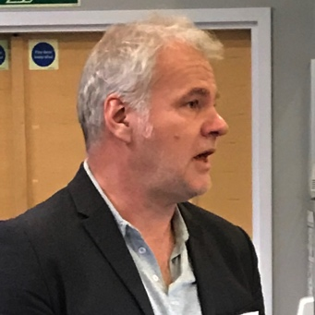
Arne opened the meeting, and said how pleased he and Sarah are that so many people are interested in helping get more music braille to more blind musicians worldwide.

He gave a reminder of the background to the project: having to produce materials in a climate of reducing expertise and high production costs; and trying to find more cost-effective and collaborative ways to produce hard-copy music braille to secure its future.
Photo 1: Arne Kyrkjebø

At our first Round Table in Leipzig in June we shared the results of our surveys and proposed four areas we need to ensure:
- the input files to be as good as they can be at the start of the process;
- conversion and mark-up tools to be accurate and reliable, suitable both for end-users and for agencies, and capable of being integrated into an agency’s workflow systems;
- good access to existing intermediary files;
- good teaching, learning and promotional resources.

Today’s agenda shares updates on 10 proposed Next Steps shared after Leipzig, which have been progressed by colleagues around the table. We have an urgent need to take action now – getting more concrete decisions to choose the roadmap and determine how development will be resourced. The project is now under the DAISY Consortium umbrella, and all info and documents are on the DAISY project webpage: www.daisy.org/project/daisy-music-braille.

Proposed Next Steps: updates with brief questions (90 mins)

1. Identify and prioritize immediate fixes required in current tools to share with developers (15 minutes)
Update from: Roger Firman (UK Association for Accessible Formats, UKAAF).

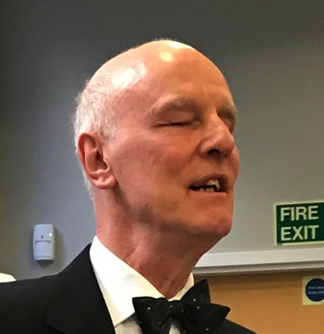
Work has started with the UK team finding out which automated conversion tools work well, and what could be improved. Testing is underway with a range of test documents of signs, combinations of signs and braille music rules. The team believes that the key issue is to improve the output from any current braille music transcription package importing a MusicXML file, involving the export of a MusicXML file from a music publishing package.
Photo 2: Roger Firman

They are starting by using MuseScore for import and export of MusicXML files, and other programs can also be tested if others can contribute to the work. The team is sending findings to Dancing Dots (GoodFeel), BrailleMuse, and DZB (Hodder) for comment. So far, testing has not covered formats/layout; or large amounts of music. This work will give a framework on which to build closer relationships between two very different starting points of stave (print) notation, and braille music.

Q: Are the results positive, or is there a lot of work to do?
A: Results aren’t all in yet, but plenty of scope to move things forward.

2. Learn from trial of DZB tools currently underway at Dedicon (10 minutes)
Updates from: Stephan Handels & Roel van Tiel (Dedicon), and Thomas Kahlisch and Hannes Kaden (DZB).

Hodder (from DZB) is being trialled by Dedicon and we are pleased to have an update from them both, especially as other agencies may wish to do the same.
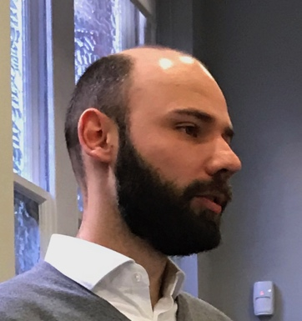
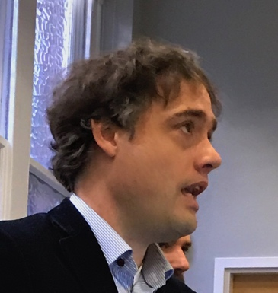
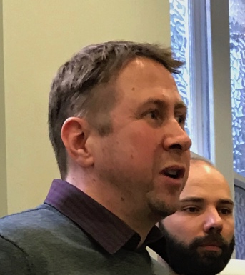
Photo 5: Stephan Handels
Photo 4: Roel van Tiel

Photo 3: Hannes Kaden

DZB explained that they started to develop Hodder 15 years ago, and have made it work beautifully with Capella to scan and OCR printed music. MusicXML import is also possible, but not yet tested systematically. The trial with Dedicon is working well from DZB’s side so far.

Dedicon reported that they used to use Finale and SharpEye, and handwritten music sheets which work well with BME, and wanted to upgrade their conversion process. They chose Hodder and their 3-month trial started in September. They will test at least 40 different types of music: handwritten music, simple and complex piano music, solo instruments, and chorus vocal music.

They will scan at 300/600 dpi and OCR it, do visual markup by braille music experts, run it through Hodder and check the final output. Aiming to eliminate the final check once they can trust the conversion tool. Progress: they are about half way through the test pieces, alongside normal production for comparison purposes. Results are above expectation, getting almost perfect translations, compliments to DZB! The challenge is still the OCR part – as a high quality original enables faster mark-up, with an almost fault-free conversion.

The trial runs until end-November, but could be extended if more testing time is needed, and conclusions will be drawn in early 2019. DZB will assess the effort and support required from their side, and are potentially open to extending Hodder availability to other agencies – but face limitations of human and financial resources.

Q: Does the OCR scan into MusicXML or another format?
A: No not MusicXML - the scan goes into Capx format, a proprietary format of Capella (this can be exported into MusicXML if you like). Matthias chose Capx because there are no ‘dialects’, so just one format always the same (unlike MusicXML). You send the Capx file to the Hodder server, and get back perfect music braille. Capx contains everything you need to create perfect music braille, but MusicXML does not.

Q: Have you tested it with mixed learning materials, text and music?
A: We will be testing this. It should be a ‘fire and forget’ process.

Q: Is Capella accessible to a blind user?
A: No.

3. Establish our requirements for MusicXML (or MNX) improvements with W3C (15 minutes)
Update from: Daniel Spreadbury, Co-Chair of W3C Music Notation Community Group. www.w3.org/community/music-notation/

Our third proposed action in Leipzig was to engage with the W3C Music Notation Community Group, to see if we could influence MusicXML now, and the development of the future MNX code.

Daniel explained about the W3C Music Notation Community Group, as one of the three co-chairs.
Photo 6: Daniel Spreadbury

It has over 200 participants from the music software business and some publishers, and blindness agencies e.g. RNIB.

It has two goals:
(1) to transition MusicXML to a free standard away from its proprietary format owned by MakeMusic (Finale). This updating work is complete, with the release of MusicXML 3.1 – but no further work is planned on the MusicXML specification.
(2) developing the successor format to MusicXML, MNX. There will be two formats: Common MNX - for common western music notation (probably of most interest to us); and another General MNX for graphical or performance music notation.

The basic specification for the Common MNX exists, and has been in development for 2 years. Important to note: it is not directly compatible with MusicXML (although it will use as much from MusicXML as possible) – MNX will only have one way to present things – tightly specified and easier to implement with no special cases required. (Compared to MusicXML which has various dialects which make it hard to know what a tool is going to do with the file and what will come out. MusicXML cannot be changed to solve the problems – there are over 300 implementations in various programs!)

The overall structure of the MNX document is very different from MusicXML; so implementing MNX will need new implementations for import and export. They are considering designing a conversion tool for MusicXML-MNX (no work on this yet) - but could be hard with so many types of MusicXML in existence.

The Group is run by volunteers, needs more people from the software world to move this all forward. All on GitHub: https://github.com/w3c/mnx

MNX is designed as a good intermediate file format between the original and the accessible format, not an accessible format in itself, so it can be used by tools to create whatever accessible formats might be required, whether it is braille or modified stave notation.

Do join the group to contribute to the MNX specification – it’s quite easy to read and we’re very active, welcome suggestions and comments. Want it to grow into something good and useful in the not too distant future.

Q: So, the vision is that MNX will replace MusicXML?
A: Yes. To make a step-change we have to make a new format with sufficient benefits, easier to implement, import, export, and greater utility for all consumers to make it worthwhile to implement.

Q: Excited to hear that MNX should allow us to produce multiple accessible formats from one file (e.g. modified stave notation, talking scores, and braille. Need this for exams. Thank you!
A: We all hope that MNX will make this much more possible than before.

Q: How are the music software publishers involved (e.g. Finale, Sibelius, Dorico)?
A: Some have already committed resources – a good sign. Need good ROI (Return on Investment) arguments for them. The benefits in publishing, to enable online consumption as well as accessibility should mean MNX standardisation is worth it.

Q: Is MNX human-readable text-based?
A: Yes, it looks quite like MusicXML, although structure might be a bit different.

Q: Does it incorporate any Midi information?
A: Yes, encoded in a text-way, just like MusicXML does. Can describe performance realisations from the MNX document, lots under discussion around this.

4. Establish and trial a MusicXML specification for publishers (5 minutes)
Update: Sarah Morley Wilkins (DAISY).

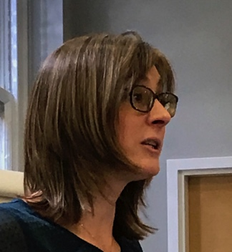
a) MusicXML specification: after Leipzig we thought that creating a specification for the MusicXML file we need from publishers would help to get better files from them.
Photo 7:
Sarah Morley Wilkins

But, in discussion with others since then, it’s probably better to influence the software MusicXML output from Sibelius, Finale, SmartScore, to get us the output we need.

Daniel commented that Finale and Sibelius have fundamental differences in how they have implemented MusicXML; there’s no common approach. Also, publishers use work-arounds to get the print score looking beautiful, which cannot be represented by MusicXML. They also often get scores from freelance engravers or composers who could make it in any way so it looks lovely in print (it’s like using MS Word with bold and large fonts, instead of the inbuilt Heading styles). Daniel believes that fixing MusicXML in publishing tools like Sibelius, Finale or Dorico won’t really help us – MusicXML can’t represent everything publishers want to engrave and vice-versa. Music is so much more complex than text, and the multiple ways of MusicXML implementation make this a really difficult situation.

Sarah commented that the effort therefore has to be on our side – for the music braille conversion tools – the scanning and conversion tools have to be clever; we need intelligent tools, validation tools, and error checking tools. Some of these exist already. Sally suggested a slight clarification – we need to develop expertise in knowing what our own version of MusicXML does with our own conversion tool. Stave notation and music braille notation are so different - a trial at RNIB has been conducted with music braille expert transcribers preparing stave notation, so the likely errors when producing braille can be predicted.

MNX was described as a beautiful step forward by Thomas for producing accessible formats, who felt that this should be a clear work area, with experts in MusicXML/MNX intermediate formats and music braille contributing.

b) Publisher charges: from the survey and recent emails, transcribers are reporting a variance in how publishers are sharing their digital files, in what format, what charge they are making, and in whether they request a contract. What is reasonable?

Through a show of hands and discussion, the majority in the room do not ask for, or receive digital files directly from publishers, and if they do, very few have had to pay for the file. Some have had to sign an agreement for personal use. The majority are working from paper copies, but almost everyone would like a digital copy from the publisher.

George had previously reported by email that “there is no requirement for publishers to provide source files to an organisation producing materials under a copyright exception (at all, or for free). Some publishers want to pass along the cost of typesetting. This is a real cost, and if the files are in a state that makes the conversion doable this is probably a good investment.” George suggests “We should state that the file transfer should be at a break-even point, because this is a non-profit activity.”

Agreed action: Draft an approach to publishers requesting more access to digital files without fee or contract, treating us as trusted non-profit intermediaries. BookShare offered to help. We will circulate for comment.

5. Establish how MusicXML and BMML can be used together, and how/if we could convert between them (10 minutes)
Update from: Gianluca Casalino and Giulio Benincasa, Italian Library for the Blind.

The benefits of BMML were described in this session, with a video and a PowerPoint presentation, illustrating how it is used in tools such as BMR (Braille Music Reader) and BME2 (Braille Music Editor 2).

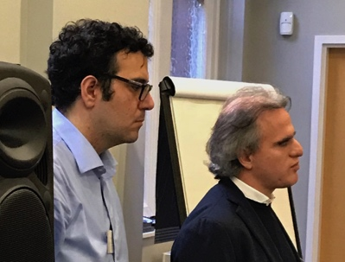
With BMML, Gianluca (as a blind musician), can navigate the score, change the layout (e.g. section-by-section to bar-by-bar) and others; it can organise the score to be a simple score, or a complex score – to support someone reading the notes, and progressing during their study of a piece (see video demonstration file in zipped folder).
Photo 8: Giulio Benincasa & Gianluca Casalino

They believe that BMML has great possibilities to describe MusicXML, and anyone can improve and develop the protocol. They hope that this group recognises that BMML is the right way to present music braille for a blind person.

The session then followed Gianluca’s/Giulio’s Powerpoint Presentation (see file in zipped folder). They would like to establish how BMML and MusicXML can work together, keeping their strengths and communicating. BMML was designed to cater for a range of user groups – from expert blind braille music users, beginners learning music, amateurs to create, modify and listen to it, and professionals. A tool using BMML offers the potential to produce music braille, both elementary and advanced, enlarged text, and spoken music. Different layouts could be made available in the tool. BMML could be the basis for the new tool to widen the market, with an investment in cash to give it the functionality it needs, create an importer that makes BMML interact with MusicXML and keep the program updated, to meet the needs of users.

6. Establish and trial the best file formats and minimum metadata needed for effective international music braille file retrieval (15 minutes)
Updates from: Ginny Grant (Bookshare); Luc Maumet (ABC Global Book Service) and Michael Katzman (NLS).

With three developing repositories of music braille scores, we wanted to know what kind of files and metadata they are planning to ingest and how easily we will be able to search for files.

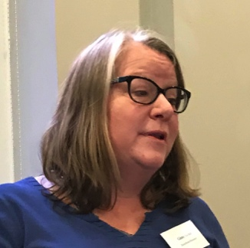
a) BookShare: Ginny gave us an update about BookShare (see Ginny’s presentation in zipped folder). Private label projects with CELA and RNIB have expanded BookShare to include music braille files. None currently available, until they ingest the files (will result in 20-30,000 titles) and do bug testing/fixes.
Photo 9: Ginny Grant

You will be able to search for and download music braille files on key metadata elements, and put improved materials back into the collection. Unlike with books, Benetech will not be doing any conversion to the files. They are creating an option to upload a single file vs automated feed; preparing for US entry into Marrakesh-ratified support for Music, and continuing requirements gathering with others with music catalogs.

New Metadata Elements (in addition to book metadata)

- Composer Contributor type, comma-separated
- Lyricist Contributor type, comma-separated
- Arranger Contributor type, comma-separated
- Opus Text String
- Movement Title Text String
- Movement Number Text String
- Key Text String
- Score Type Full Score, Open Score, Single Line
- Instruments Text string, comma-separated
- Vocal Parts Text string (e.g. SATB, SSAA, SAB, etc.)
- Music Braille Format Bar by Bar, Bar Over Bar
- Other? (e.g. Section by Section?)
- Chord Symbols Yes/No
- Book metadata includes ISBN, copyright info, distribution rights, synopsis, producer, funder, BISAC/categorizations, transcriber, etc.

Q: Is the metadata standardised?
A: Yes, as it’s ingested from CELA and RNIB, and it’s readable in Onyx record and documented. No additional accessibility metadata in there at the moment – but we’ll work on that this year for all Bookshare’s records.

Q: Any other catalogues coming online?
A: Yes, we can ingest other catalogues into Bookshare’s private label.

Q: Can you just search, or download too?
A: With our API, you can search books as well as music files with one search. You can download, and upload new versions too.

b) ABC Global Book Service: Luc presented next via Zoom (see Luc’s presentation in zipped folder).
Since his report in June, the WIPO ABC Global Book Service now has 45 participating libraries, with 5,000 music scores. The Book Service supports the Marrakesh Treaty, and participating libraries. The metadata for braille music scores is automatically mapped and merged into the ABC Book Service Centralised Catalog; taking metadata provided by the libraries. Identified additional metadata needed to facilitate cross-border exchanges: Formats, page layout, and what’s on the original braille music scores themselves. The original metadata for each braille music score is also visible.
Metadata fields received after the meeting:
ABC Global Book Service - Metadata Requirements (English)
This spreadsheet lists the catalog information needed by the ABC Global Book Service to include the full catalog of an Authorized Entity (AE). For established libraries with a catalog system, our preference is to use MARC21 or similar standards for the provision of this information. If an AE can provide XML in MARC21 format, we will supply a separate spreadsheet designed to include and map MARC21 field names. Other libraries may only be able to provide catalog data in a spreadsheet. This spreadsheet lists the data that should be provided in this way.
Please note, metadata should only be provided for accessible versions that have been produced by the AE that is joining the ABC Global Book Service and that conditions within the ABC Global Book Service AE Agreement have been met.
Field | Description | Status
Unique Identifier | A unique identifier for each accessible version (Braille, DAISY, MP3 etc) that is used by the AE as the filename of the book that would be supplied to ABC when requested by another AE. | Mandatory
Language | The language of the original publication and accessible version e.g. English, Spanish, French. We prefer to use the ISO 639-3 standard that uses three letter abbreviations e.g. ENG for English. | Mandatory
Country of Production | The country where the accessible version was produced. We prefer to use the ISO 3166-1 alpha-3 standard that uses three letter abbreviations e.g. NEP for Nepal. | Mandatory
Audience | The audience that the original publication and accessible version is appropriate for e.g. Adult, Teen, Child. | Preferred
Author | The author, preferably provided as [Last name, First name] | Mandatory
Title | The title of the original book and accessible version. | Mandatory
Sub-title | The sub-title of the original book and accessible version if applicable. | Mandatory if the accessible version has a sub-title.
Producer name | The name of the Authorized Entity that produced the accessible version. | Mandatory
Production city | The city in which the accessible version was produced. | Mandatory
Production date | The date when production of the accessible version was completed. | Mandatory
Copyright statement | The copyright statement that is added by the AE and is required by the national law of its country e.g. "This electronic copy of the original work is made under a Copyright Licensing Agency licence by Seeing Ear. It is for the personal use of a print disabled person and may not be further copied (including any electronic copying or transmission), or dealt with without permission, save as may be permitted by law." | Preferred
Publication ISBN | The ISBN code of the original publication. | Preferred
City of publication | The city where the original publication was published. | Preferred
Publisher | The publisher of the original publication. | Mandatory
Year of publication | The year that the original publication was produced. | Preferred
Subject headings | The subject headings that apply to the accessible version e.g. educational, crime thriller, romance, biography etc. Note: ABC is in the process of defining categories in its system. In advance of this, it would be helpful to include subject coding or descriptions. | Preferred
Format type | A value that enables ABC to determine its "Format Filter". Format filters are: MP3, DAISY Audio, DAISY Audio with Text, DAISY Text, DAISY XML, BRAILLE Contracted, BRAILLE Uncontracted, BRAILLE All Contractions, BRAILLE Music. | Mandatory
Format detail | Detailed format information e.g. DAISY 2.02. | Mandatory
File size | The size of the accessible version in mb. All files provided are to be in a single .zip file. | Preferred
Narrator | Name of narrator [Last name, First name] for narrated audiobooks. | Preferred if applicable.
Duration | The play time for an audiobook if applicable [hh:ss] | Preferred if applicable
Production status | Available (it has been produced) or In Progress (it is planned to be produced or is in the process of being produced). | Mandatory
Synopsis | A summary of the content of the book. It is important only to include text that is not subject to any copyright restrictions. | Preferred if applicable
Publisher permission | World if permissions obtained for cross border exchange within ABC is for all countries. If there are any territorial or country restrictions to permissions received, these should be included. | Preferred if applicable and available
Publisher that provided the permission. | The name of the publishing organization that has provided permission for cross border exchange within ABC. | Preferred if applicable and available

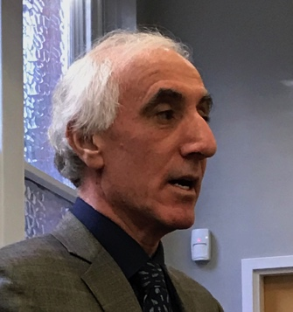
c) National Library Service, Library of Congress: Michael then gave us an update on their progress towards a music braille repository. The implementation legislation has now been signed by the President to implement the Marrakesh Treaty, and national law been changed to include music braille exemption. Mainly dealing with embossed braille, mostly through contractors – so like Arne, the easier it is for them to produce music braille the more braille they can get from them! The NLS is part of the Accessible Book Consortium, so they can provide files through ABC. Working with lawyers to work out how much of our collection can be shared [overseas] because of some funding restraints. Also, for their US patrons they will be providing refreshable braille displays. Format for music braille will be BRF files, though if BMML was required they could update the devices to interpret those files.
Photo 10: Michael Katzmann

Q: What is the situation with your BARD service - will that still only be available in the USA, or more widely?
A: BARD lets US residents download braille files to their braille display, smartphone or tablet via an app. NLS’s legislation and appropriation used to create our accessible formats does not (currently) allow us to share files internationally. However, we have a desire to add a footnote to the legislation to share the files internationally.

7. Trial outsourcing music braille production to an off-shore agency (10 minutes)
Update from: Arne Kyrkjebø (NLB).
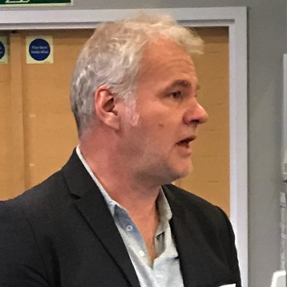
Arne described the current situation in Norway for the production of books and magazines in different formats, and what he plans to do as a trial for music braille. The Norwegian Library of Talking Books and Braille (a governmental agency) currently uses commercial services in India to convert books and magazines in different formats into their specific ePUB standard, used for their internal production of ePUB, braille, and talking books.
Photo 11: Arne Kyrkjebø

They are starting a project with an existing supplier to convert paper music or PDF into MusicXML:

- Goal 1: to produce a set of perfect MusicXML files, to test with the existing commercial tools. We know that good input files get good outputs.
- Goal 2: how to produce that perfect MusicXML file – what improvements, guidelines, mark-up instructions are needed, to create MusicXML for our purposes.

- Goal 3 (later on): whether we can outsource more of the conversion to an offshore agency and what skills, business model, support etc would be required.

Currently working on the contract, and hopes to start as soon as possible. The agency will need to build up/obtain the resources they need, building on their existing XML skills. Maybe other agencies will be interested in joining forces to make this a sustainable model.

Q: where will the MusicXML come from for your trial, Sibelius/Finale? Will that then be converted into braille?
A: First, we want to try getting the best files possible. Later, we might be able to go further to do braille conversions – but need to test the files with the tools first, e.g. Hodder, GoodFeel, BrailleMuse. Getting good files is the basis of the discussion.

Q: Will you use MusicXML as the output file, or anything else?
A: MusicXML only (we think).

Q: Which dialect(s) will you choose of MusicXML?
A: Hard question – need to find the one which maps best to the tools, and upcoming MNX.

Q: Why don’t you use volunteers to do the sighted markup, as it doesn’t require any expertise in music braille to do this?
A: NLB doesn’t use volunteers, it’s a Government-funded library, so it’s an established commercial business arrangement.

8. Review specification documents for existing conversion tools, including Haipeng Hu’s proposals, to prepare for the requirements capture process (10 minutes)
Update from: Sarah Morley Wilkins (DAISY).
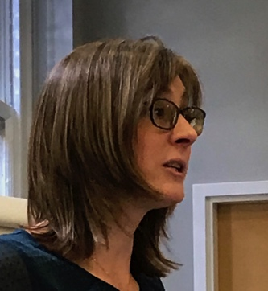
In addition to identifying immediate fixes (action #1), we also talked about a longer-term strategy for improvements, to make a step-change in the tools available. We proposed documenting our requirements for a tool, and writing a specification for that technology to meet those requirements, whether in the scanning and mark-up, error checkers and validators, languages and layouts, to support different kinds of users.
Photo 12:
Sarah Morley Wilkins

Haipeng Hu came to our attention because he’s used almost every tool available to try to get the best results for music braille, knows their strengths and weaknesses, and is in dialog with the developers. He has written a specification framework already for a new transcription tool which is independent of any existing tool and is not constrained by the limitations of any tool.

We have invited him to present and discuss his specification, but please consider it in two ways: firstly as an example of what a new tool could look like if it were built from scratch – and secondly, as an example of how a specification like this could improve existing tools.

Remember, this project is to secure the future of music braille production, particularly paper-based, in a field which is rapidly losing its music braille transcription expertise. It is to give blind musicians the flexibility of having a paper version when they want it, and the digital file when they want that. It is also about using our existing sector expertise to influence the future tools; being able to get more scores produced and shared with more blind musicians; and being able to educate and engage a new generation of transcribers and teachers so that this vital knowledge is not lost forever.

This work has to be based on user requirements we agree and document, and then how those requirements are met by a specification, and then how affordable and achievable it is in the current economic climate. As with any collaborative work, elements of compromise are likely to be needed to achieve consensus. We should keep our goal in mind when we discuss our requirements so we don’t end up with a long shopping list of unachievable features.

Alongside this ambition, developers will have their own views about the direction they wish their tools and businesses to take, and they may, or may not, wish to engage with us in this dialog. We hope they will. And we hope that some of them wish to come on this journey with us to help us secure a future sustainable tool.

The financing of major technical development is usually not trivial, and securing investment funding in an appropriate way will be important. There are various ways for DAISY to move forward, and today we’ll hear some of them so we can make our plans.

DAISY, as a global organisation of libraries and agencies for the blind, and related organisations, has an existing infrastructure for securing collective contributions and fundraising for development projects, which has been successfully used before for similar activities. DAISY has a strong network of partners and funders, including Google and Microsoft for example, who could be influential in our efforts.

Kevin Carey from the World Braille Council will talk more today about the development model he’s used before for the Orbit braille display project as an option for music braille technology development; and Bill McCann from Dancing Dots will talk about his vision for tool development. We look forward to hearing other views during our discussions today as well.

Our intention is that by the end of today’s presentations and discussions we are in a position to agree some clear next steps for this activity, and reach agreement for which agencies can help take it forward – please bear this in mind as you listen to the presentations during the rest of the day.

Update from: Bill McCann, GoodFeel/Dancing Dots

Bill is on the agenda after lunch, but as a few people will be leaving the meeting this afternoon he was given a few minutes now to introduce his topic.

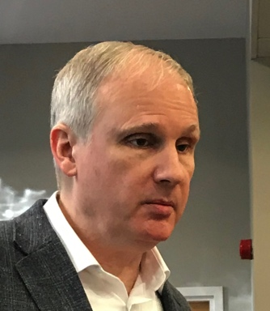
I started Dancing Dots in 1992, because I’m a blind musician and through my education I could never get music scores in a timely way. Released GoodFeel in 1997. Business Partner Albert Milani develops GoodFeel, and James Aitken develops Lime - the music notation program in GoodFeel. Developed something so I can read and write scores. I can read in a multi-modal presentation, can feel it on my braille display, hear it verbally describe in Jaws/other, and hear the pitch of the note. A sighted person can see the music on-screen at the same time. Using the braille window you can see the braille change in real time if you edit the score. Our system does not require them to be a music braille expert, just an expert in print music. This afternoon I’ll show a file we got from Hal Leonard, a publisher in the US, and create a talking score. Later, I want to talk about leveraging what we’ve done so far and automate as much as possible. Obviously some mark-up is needed, but if we get better source files, we’ll get better braille. And if we can automate as far as possible, we can get lower costs.
Photo 13: Bill McCann

Q: Can you also support low-vision users?
A: Yes, Lime Lighter can do screen magnification too, zoom up to 10x and can scroll with a pedal.

9. Establish ways to document/harmonise country codes and layouts to facilitate file sharing and conversion, with ICEB (English Council on English Braille) and World Braille Council (5 minutes)
Update from: Roger Firman (UKAAF/ICEB).
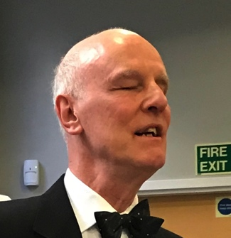
Photo 14: Roger Firman
Braille music manuals have tended to concentrate upon signs and how they are used, rather than presentation. Perhaps it has proved hard enough to complete that task, let alone cover braille music formats too. We need also to be aware of any differences between paper and electronic versions and ensure they are incorporated.

If we are wishing to take full advantage of what music technology and publishing offers, we need to address harmonisation and standardisation. Setting new standards for braille music production and presentation is a goal we can achieve, given the desire by those involved to do so. Learning what the World Braille Council has in mind will be an important factor in taking this forward.

10. Discuss with World Braille Council their planned Music Braille Summit in Paris 25-26 April 2019 (10 minutes)
Update from: Kevin Carey (World Braille Council) – ‘Music Braille – What can we learn from the Transforming Braille Project? The Orbit Project’.

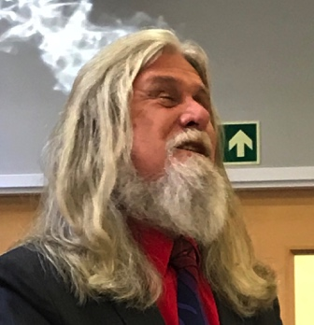
Kevin announced that there will no longer be a World Braille Council meeting on braille music in Paris - since the DAISY project meeting in Geneva is mid-year, we don’t need another meeting 6 weeks before that in Paris. So, the WBC activity on braille music will merge with the DAISY project, for efficiency. Kevin wanted to explore whether the music braille community can learn anything from what he did with Transforming Braille project for Orbit.
Photo 15: Kevin Carey

See Kevin’s full presentation (in zipped folder) which is summarised here:

After the 2011 Braille 2020 conference in Leipzig, Kevin on behalf of RNIB, led a global initiative to address a potential crisis in literary braille – to produce a refreshable braille device for 10% of the cost of products on the market. A user requirement was drafted and circulated, for a $300 20-cell display. Additional features would have added significant cost, and were not needed for a simple, cheap device for children and braille display users. A $250k research project was funded by contributions from agencies of and for the blind, to survey all braille display projects, and an independent engineering company scored and weighted them against the requirement, resulting in three possible solutions.

A Limited Liability Company was set up, and organisations could buy shares to develop a device which would enable blind children in developing countries to acquire braille literacy; and cut the cost and increase the volume of library titles in rich countries. The weight of opinion of shareholders was based on their share purchase. Bluetooth was added, so the price rose to $320 ex-factory for shareholders. The resulting Orbit 20 Reader is now in factory production, and the largest investment of any organisation was £250k to solve a problem none of the organisations could have afforded to solve alone.

Music braille is faced with the following similar problems: Expensive to produce; Challenged by digital systems; and a Shrinking pool of expertise. How badly do organisations want it to survive – some may prefer to invest in digital systems – but concern needs to be matched by investment. Automation is the only viable option, so that music braille is produced in file format for a braille display, underpinned by a large ‘Help’ function which explains more difficult aspects of the code. An agreed procedure, requirements, and ranking with reference to cost will be needed; with a policy consortium open to producers; who will need to accept collective solutions. We need a political and financial process, not a technical process. Settle on the objective, then harness the best technical solution.

Q: Agree there’s a trade-off between cost and features. To secure the future of music braille we need to engage young learners who need music quickly, and give teachers easy and fast solutions at low cost.
A: It took 20 years to get UEB agreed to improve automation, but then a detailed debate took place about a single quote/apostrophe. Be careful not to let that happen here too.

Music Braille Tool Specification Presentation and Discussion (90 minutes)

See Haipeng’s full presentation (in zipped folder) for full details of his speech.
Specification: www.brailleorch.org/en/framework/
Website: www.brailleorch.org/en/about/

Sarah introduced Haipeng: Arne and I are delighted that Haipeng has been able to join us from China for this meeting. He is a blind musician, transcriber and composer, and the founder of two projects of significant relevance to us, with an enviable range of experience to share. He is an expert transcriber, converting some of the hardest-to-find, largest and most complex orchestral and chamber music into music braille, and making them freely available on his online collection to other blind musicians (The Open Braille Music Project). Haipeng has personally transcribed more than 8,500 print pages into music braille over 3 years; and with the help of the UK company Scores Reformed in the last 6 months, has transcribed more than 5,000 print pages this year alone.

Additionally, with his extensive experience in using existing conversion tools, Haipeng has written a proposed specification for a tool which brings together all features and functionality we might need, now and in the future. This is the only kind of specification document that we know of for a tool, and we should consider it as the criteria for improving existing tools, as well as considering it for the description of a new tool. We’re hoping that by Haipeng kindly sharing his proposals with us, we can start to see the way to making the improvements we all hope to see in tomorrow’s tools. Over to Haipeng…

Haipeng Hu - a music braille tool specification framework

The text from Haipeng’s PPT slides are included here as a summary of the presentation, and Haipeng’s full presentation (in zipped folder) is also available.
Photo 16: Haipeng Hu

A Music Braille Tool Specification (Slide 1)
- Haipeng Hu, China
- hhpcomposer@gmail.com
- www.brailleorch.org/en/about

Introduction (2)
- Graduate of Wuhan Conservatory of Music
- Founder: BrailleOrch and Open Braille Music project
- Difficult to find chamber and orchestral scores
- Tested many transcription and notation tools
- Work with composers, engravers, publishers
- GoodFeel, Braille Music Editor
- BrailleMuse, Hodder

Comparison of main tools (3)
- GoodFeel
- Braille Music Editor
- BrailleMuse
- Hodder

Features and limitations (4)
- Braille editing needed, limitations on layouts
- Led to a specification for new or existing software
- MusicXML or MNX into BMML
- For professionals
- Highlights of the specification…

1. Universal use (5)
- Output various braille formats
- Menus and messages user-editable

2. Accurate transcription (6)
- Smart, flexible algorithm for cleaner results
- Sourcing the scores:
  - Improved scanning/engraving services
  - Publishers give their source files
  - Publishers convert source files themselves
  - Artificial Intelligence (AI) tools do conversion

3. Project concept (7)
- Not a single braille music file
- An integrated container for all necessary files
- E.g. MusicXML, MNX, BMML, literary braille, images
- Can create mixed and multiple volumes easily
- ‘Split’ and ‘Merge’ allows collaboration
- Text and structure formatting

4. Flexible formatting functions (8)
- Powerful layout and formatting options needed
- Single source to create different formats/layouts
- Enhanced BMML most flexible
- Integrated literary braille converter and translation tables
- Part-management tool for ensemble scores
- Interval directions can be modified for different conventions

5. Powerful editing and correction (9)
- Flexible editing and correction functions needed
- Marking, search and replace, substitutions, line breaks, ‘Reformat’
- Combine or split multiple measures easily

6. User-serviceable functions (10)
- Handle special transcription cases
- Software updates for MusicXML/MNX
- Powerful ‘Debug’ and ‘Define New Features’
- MusicXML/MNX displayed alongside BMML to identify errors

7. Copy protection mechanism (11)
- Irreversible encryption to prevent data extraction
- To protect publisher scores from being printed
- Can remove source from project

8. For blind music learners (12)
- Clear and powerful navigation and reading
- JAWS and NVDA
- Braille display, speech and Midi playback
- ‘Play-Along’ function
- Convert MusicXML/MNX files for embossing

Three models (13)
- To suit economic conditions and technical needs:
  - Free – Lite version – for personal use
  - Standard – for transcribers and professional personal use
  - Pro – for transcription agencies
- Single installer, with 30-day evaluations, easy unlock
- Revolutionary change: software, source file, markup

Source file limitations (14)
- MusicXML 3.1 and customized engraving
- Sibelius, Finale, MuseScore
- Need to improve both MusicXML export and MusicXML and MNX formats
- ‘Define New Features’ for mapping exclusive fonts
- Scanning tools: SharpEye, Photoscore, PDFToMusicPro
- Symbols missing and uses old MusicXML 1.1 or 2.0
- BMML: MusicXML 2.0; add elements and parameters

Conclusion (15)
- Specification for a new tool, or to improve existing tools
- To overcome limitations of existing tools
- My ideas – your suggestions are welcome
- To get a sophisticated music transcription tool to benefit all blind musicians around the world

Questions and discussion
(Grouped by theme, not necessarily in the exact order they were raised)

Why use BMML rather than MNX?
- Because it’s not going to be possible for MNX to include braille elements we need.
- BMML is a good bridge between any notation format including MusicXML/MNX into braille as it accurately describes what is needed for braille.
- The proposed specification could use any format we decide.

Let’s follow/integrate with mainstream code and tools to stop us being in a braille ghetto forever. Could we agree a minimum/essential product to build?
- It is a niche market, hard to make it mainstream. Could sum up the core functions of the specification which could be the minimum tool.
- Could have a tool/functions for simple content; and functions for complex content. Aim to maximise automation for both.
- EPUB3 development is a good parallel – started with IDPF creating a mainstream market to support accessibility. If we support MNX, we hope publishers will use what’s created.
- Open standards are good for accessibility.
- Probably not enough to have only a simple set of functionality.
- Could aim for say, 80% automation with the rest done manually – since a large diversity of music publishers.

Let’s get requirements into MNX.
- In defence of MusicXML – there are lots of things which can be shown which don’t have braille equivalents; and we do already have a minimum viable tool – and exceeded it by a long way.
- It’s hard for a scanning tool to process every possible layout from a print publisher (who makes a beautiful printed score in a variety of ways).
- There is a use for ‘quick and dirty’ or ‘quick and simple’ scores especially in education – that’s where sustainability lies.
- Impossible to expect 100% fully automated music braille production.

Music is a knowledge domain, like chemistry and maths.
- Need to use the best format (e.g. MNX) and tools to convey the semantically rich information for use on the web and refreshable braille.

User perspective is important.
- Students need to read and write, be creative. Need a multi-modal tool so blind/sighted can work together.

Maybe 4 steps needed:
- The source from the publisher to MNX (from publisher or scan it ourselves); (2) markup – e.g. in Finale; (3) Automated conversion; (4) Quality control (which can be lower once we know it’s going to be good). We need a roadmap for these steps, to come to this result. Don’t try to get to the big end goal without these smaller steps.

Such a range of needs.
- Simple introductory teaching and learning materials, and for people to be read and explore music themselves; right through to the needs of professional transcription agencies who need to be able to service highly complex scores for professional performers.
- A one-size-fits-all solution is probably not possible.

Use the specification to review tools.
- It’s the first time someone has written down what the features are that we might want in a tool, based on the strengths and weaknesses of existing tools. We can review existing tools against Haipeng’s specification - some will do very well, though there might be some more development to do.
- We also need to hear from those businesses/organisations to see if they’re interested in servicing the future world-wide music production industry.
- It would be good if conversion tools could automate multiple bar repeats in piano music, repeat lyrics, and line breaks at the phrase rather than bar (raised online).

Do we need to build a new tool, or could your ideas be implemented in existing tools?
- It will be most efficient to try to improve existing tools; that’s why Haipeng chose BMML for expediency, but could use another format.
- Being able to write, read, and edit music is all important. BMML is the best way to do this in our opinion.
- MusicXML is in most use today, and we could use MNX if it is complete enough.
- No development workplan written yet; but we can improve BMML to include more symbols with my experience, and can try to get features into MNX.

Summing up (Arne)

- Standards – need the source file against some kind of specification – and the tools to work to meet that specification.
- Conversion part – need to look at where the tools are today, and the possibility of improving them against the specification.
- Business model – for the agency (needs support, updates, longevity etc), as well as for the provider of the tool (needs to be sustainable for years to come). Some tools are commercial, some are non-profit – how will those go forward?
- Source file – want to have a useful source file from publishers, other agencies, standardised.
- Have to make some choices together soon to get results, choose a path, and follow it to the end.
- Consequences – might not be the perfect choice for everyone – we can’t win – but a chosen path means we can move forward.
- Have to do it soon. Already limited the focus of this project (e.g. omitted teaching and learning aspect, which are still important, but have to choose what we can work on).

A Roadmap for the Development of Music Braille Tools (30 minutes)
Update from: Bill McCann (Dancing Dots)

Sarah introduced Bill: the Founder and President of Dancing Dots Braille Music Technology in the USA, and he’s one of the longest serving music braille technology specialists in our sector. As a blind musician and programmer, Bill Founded Dancing Dots in 1992, and released GoodFeel in 1997, their first software to automate the production of braille music scores. GoodFeel is used all across the USA, and in over 40 countries world-wide, and has incorporated a wide range of features and functionality to support different kinds of production, and even exploration of notation by blind musicians. Bill was a semi-professional trumpeter, composer and arranger, and is passionate about tools which make life better for people with disabilities, especially when it comes to the teaching, learning and performing of music. We’ve been talking in recent months about our future needs for tool development, and Bill offered to talk about his idea for a roadmap for music braille tools.

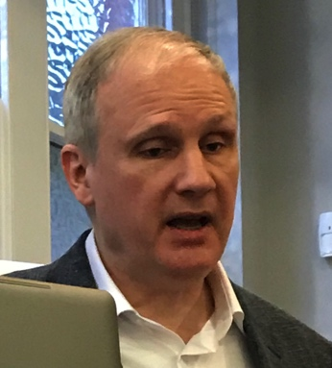
Bill wanted to talk more about their technology, how it works, and compare GoodFeel against the 12 points in Haipeng’s specification - it’s good and can be better, with enough time and money.
Photo 17: Bill McCann

A summary of Bill’s presentation follows, and his presentation slides and sample files are also available.

Bill’s introductory slides (in zipped folder) showed how GoodFeel can now use other screenreaders, Jaws (also supports braille output), NVDA and Narrator. It contained a demo of a talking score; which plays, describes the notes, displays output on a braille display and on-screen – breaks down the walls between blind and sighted musicians. Also had a demo of a blind customer who used Lime to print out her composition and heard it played for the first time. Can also emboss a braille hard-copy of the score. Played Bill’s GoogleCar song – used Lime to write it down himself, the song, words, piano part and guitar symbols; then sighted musicians read the print score, blind used braille, low-vision used large print.

Bill’s Second Presentation slides (in zipped folder) introduced Albert Milani (online) and James Aitken (in the room) as the bright coders who’ve made all this possible. The slides included images of interesting travel and invitations, including to the White House; and an image of James Risdon exploring by touch the bust of Louis Braille at AVH – taken from the excellent film ‘Braille Music’ available on Amazon Prime: www.amazon.co.uk/gp/video/detail/B077H6GJMD.

GoodFeel automates transcription of printed scores into accessible talking scores including braille, music, verbal and music cues. With Lime Aloud (gives talking scores), and Lime Lighter Suite (low-vision tool). Dancing Dots now owns Lime, to secure it for the future, so it will get more accessible. Can write music in the tool, or import MusicXML.

Bill’s sample files (in zipped folder) are available as demonstrated: Demo’d importing file ‘I dream a dream’ found on MuseScore; explore chord by chord; hear it at any tempo; braille is showing on braille display and in the braille window at the top of the screen too. Demo’d importing a file into Lime, open in GoodFeel, used Braille View to see the actual music piano part which Jaws tries to read.

The way forward: The slide shows how GoodFeel meets Haipeng’s 12-point specification, and where there are things which could be improved. E.g. could add section-by-section, depending on demand. But, this isn’t mainstream technology – niche and small market – we must pool our resources. The sale of other technologies and solutions helped fund development of GoodFeel. Dancing Dots has max of 4 people in it – small group dealing with a big problem. Anyone can try a demo version of GoodFeel to try it out.

We need to:
- make stand-alone validation tools – to validate the source file, so software doesn’t try to process garbage.
- Make Lime better and XML import better (though it’s already good).
- Make GoodFeel better and flexible (use ‘official’ chord symbols)
- Agree minimum number of formats, or dictate them (braille music tsar!).

Decide our priorities, make a workplan, and costs, to try to satisfy the need to get quality scores, fast braille, and sharable files. Find people who care with time and money to make it happen.

Q: is Lime still free, so teachers can download and write music for students to use in LimeAloud?
A: Dancing Dots makes the public version of Lime, no accessibility features. Available for teachers to download. Students read it using LimeAloud.

Open discussion and next steps (90 minutes)

The size of the meeting was not conducive to splitting into working groups, so the discussion remained open to the whole group. It was wide-ranging, and the topics are listed here grouped where possible, so not necessarily in the same order in which they were raised.

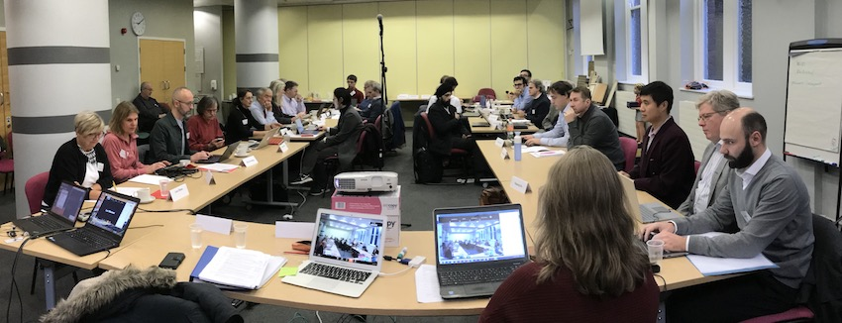
Photo 19: The meeting room and most of the participants

- Arne proposed two certain next steps:
- We will use Haipeng’s specification and create a requirements document, for everyone to comment by deadline, and agree the specification.
- Contact all suppliers to ask how they can meet it.

Other suggestions raised/discussed were:

- Requirements should cover two aspects: 1) requirements for source file; and 2) for the conversion tool. Both need to be improved for maximum automation.

- Scoring should cover the whole process – e.g. level of effort and quality of output.

- Use sighted musicians to do file mark-up to get a good input file (trial in India), and establish guidance and choose an input file standard. Will test with conversion tools, to get knowledge of errors etc.

- Same as ePUB3 mark-up in Norway – they get ePUB3 files from publishers, send to India who mark them up according to NLB’s requirements – both files are ePUB3, but the one they get back from India is the complete file we need for production.

- No further development work will be done on MusicXML, so no opportunity to influence.

- MNX to be influenced so it gives correct underlying structure, especially for text in scores. Need to give W3C details of what we need in MNX (i.e. examples of what can’t be done/what’s wrong with MusicXML; e.g. fingering, arpeggio marks).

- Ask W3C to show us ‘good’ MusicXML 3.0 markup so we can test it in our different tools.

- Need to know what the tool we use does with the MusicXML we receive. Do Hodder, GoodFeel, BrailleMUSE have this documented?

- Semantics of the print stave music notation mean it’s hard to fully automate into braille; especially when they’ve done a ‘work-around’ for print layout so underlying structure is not ‘true’.

- Two views: (1) Transcription of braille text itself needs rules, so we need similar mark-up language for braille music (2) We don’t need braille-specific extensions - if you write MusicXML properly (accessibly) you benefit everyone.

- Validator – all the files we receive could have ‘valid’ MusicXML, but some will be better than others. Need to find the ‘best’ one we could use as our standard, and develop rules to mark it up well for our tools. Then we can ignore files that don’t meet the basic standard for accessibility, and the conversion tools can develop based on that standard.

- Automated fixes – the validator would check the file, and do as much automated fixing as possible (as some tools do now already, e.g. Capella and Hodder; and OCR for maths). Capx files are very easy to fix.

- Could we improve MusicXML output from Sibelius, Finale etc? Probably not now. It’s voluntary compliance – publishers want it to look nice, the underlying structure isn’t important to them.

- What about unifying music braille – like for UEB? Who would take that forward?

- UKAAF had four requests for the future work, devised in consolation with users and ICEB:
- Agree that the major issue is to improve the output from any current braille music transcription package importing a MusicXML file
- Agree that the focus of the work should be on MusicXML to braille music (not any desirable side line such as screen reader access to any notation)
- Agree that country deviations and additions to NIM should be collated and shared, adding that if WBC approve BANA 2015 this replaces NIM standards
- Agree that the different layouts required for electronic files designed for electronic use should be addressed and differences with hardcopy articulated.

- Consider the purpose of the user of the music braille; so we can give them what they need in the way they need it (10 year olds want to play, not read 3 pages of explanation, or they give up).

- Documenting music braille language tables and layouts, and differences to NIM – at least UK, Australia and Netherlands have done. Then could see commonality to start a more standard approach. ICEB needs more countries to respond. Not in WBC remit, but does want less anglo-centric work. Make decisions based on what’s easiest to automate. Who could do this work? Not DAISY’s responsibility.

- NIM 1996 left out format as the discussion was so difficult. We should limit the number of options available, create a standard. At least if the music signs are the same people can usually process different layouts. Some countries may be willing to accept alternative layouts.

- Agree the user requirement, and get the process in place to agree the solution. Huge amount of work to address a relatively small problem.

- Through these discussions we are trying to identify and define our problems for the requirement. And knowing some of the solutions helps – we can try to standardise (inputs, tools) which makes it easier to find solutions and pool our resources to find a common solution.

- Need the process to ensure that minorities who disagree with the solution will accept the standard. We are not the police and some organisations will want to choose a different path to suit them; though all have an interest in working together to solve our common problem.

- Want to encourage compromise for the greater good, especially where it improves automation, and quicker easier access for children.

- A well marked-up source file will enable us to produce materials for different user needs - simple scores and complex scores - if the software offers those options for layout, and leaving out symbols until children have learned them.

Close

Sarah closed the meeting, hoping that the meeting had brought people up to speed and involved them. She, Arne and others will digest the big issues discussed, and will make some proposals based on the requirements we’ve discussed today and in Leipzig and circulate them. She thanked agencies and individuals for putting their cards on the table and sharing their views, and for so many people joining with our activity this year.

The next Music Braille meeting will be scheduled around the next DAISY meeting 27-29 May in Geneva – exact date to be confirmed, likely to be the 28-29th. We hope to have a day, or a day and a half on requirements specification for selecting the software and standards. With so many months till then we have lots of time to progress work by email, skype, or via reports to each other.

She asked for agencies to step forward and help – we are the people who can do something about this – but we have to do it, even with competing resources on our time. We are the people to make the change.

We all want to be able to have another meeting where we can share substantial progress again, like we did today. Really pleased with the collaboration of volunteers donating their work time (and private time) to do so much substantial work since we met in June. Thank you everyone.

Annex – Teaching and Learning of Music Braille

The meeting was pleased to have many participants who are interested in, and engaged with, the issue of supporting learners of music braille and young musicians in education.

Whilst the meeting did not have opportunity for any updates on this topic, there are three recent papers from the Nordic Braille Meeting in Oslo 19 October, which will be of interest to many, as well as a research paper on the teaching and learning of braille (generally) which may have some relevance to our interests too. Shared here with permission of the authors.

It would be wonderful if interested parties are able to collaborate to share and develop further resources.

See files in zipped folder:

- Braille Music in Swedish Schools, Sara Backström Lindeberg.

- Reflections based on my experience with production of musical notes in braille and with training in their use in Norway, Pilar Menéndez.

- Why is competence in braille music so crucial to blind musicians? Nina Tveter.

- Braille Teaching and Literacy: A Report for the European Blind Union and European Commission. January 2018. Danish Association of the Blind and the International Council for Education of People with Visual Impairment and Dr Sarah Woodin

