DAISY Music Braille Project – Phase 2 Research Questions
10 April 2018

Dr. Sarah Morley Wilkins, Project Consultant, DAISY Music Braille Project
Arne Kyrkjebø, Norwegian Library for the Blind
Manfred Muchenberger, Swiss Library for the Blind
musicbraille@daisy.org

Introduction to Phase 2

Arne’s initial call for a DAISY Music Braille Collaboration, and comments received to our Draft Research Outline earlier in the year helped to identify a number of related initiatives, groups and products across the sector, whose activities will inform specific aspects of music braille production in future. The additional contacts we were given in that first phase are being included when we circulate this second phase or research – thank you in advance for your participation too.

The overall goal for most of the current initiatives is the same, though they may focus on one element or another – to ensure that more music scores are available to more musicians in a timely and cost-effective manner.

The various key issues surrounding the success of music braille include: the teaching and learning of music braille; the promotion of resources and services available; the development of tools to help with production of hard-copy braille; and the development of new technologies such as refreshable braille technologies capable of displaying music braille files.

Of everything covered in the Draft Research Outline, and many useful comments received from 15 responding agencies/companies, we have captured many views and suggestions, which have informed this next phase of the project.

The factors and processes involved in the production of music braille are numerous and diverse (the flowchart below with following Alt Text tries to capture these stages). The shaded area around OCR Software and Conversion Software/Suite is considered to be the ‘Black Box’ area where various tools work their magic.

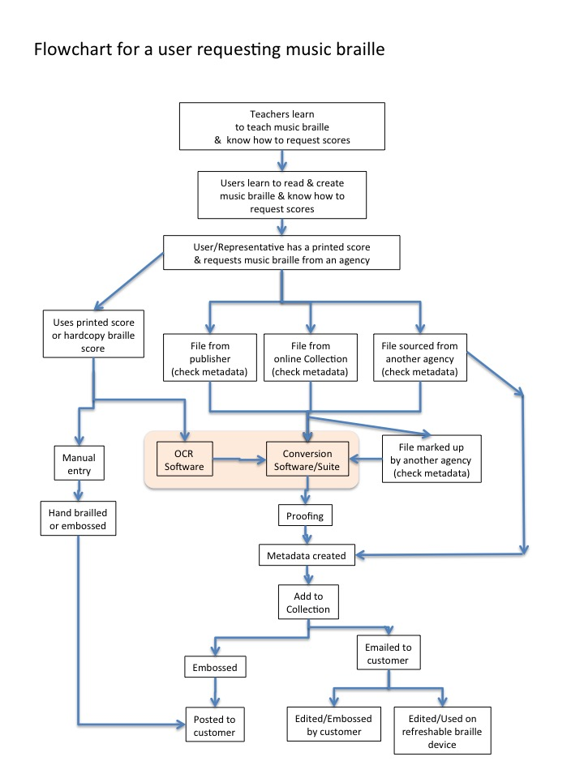

Alt Text for image ‘Updated flowchart for a user requesting music braille’
Teachers learn to teach music braille and know how to request scores.
Users learn to read and create music braille and know how to request scores.
User/representative has a printed score and requests music braille from an agency:
- Uses printed score or hardcopy braille score
- Manual entry or OCR software and conversion software/suite, maybe also then proofreading, metadata created, added to collection, embossed/emailed to customer, edited or embossed by customer or used on refreshable braille display.
- Alternatively, hand-brailled or embossed, and posted to customer.
Agency sources file and checks metadata from:
- Publisher, online collection, or another agency.
- Goes through conversion software or file marked-up by another agency (metadata checked)
- Proofreading
- Add to collection
- Embossed and posted, or emailed to customer
- User edits or embosses the file, or uses on a refreshable braille display.
End of Alt Text

Of the numerous areas identified in the Draft Research Outline, there seem to be three or four main areas which perhaps the DAISY collaboration should focus on, keeping in close touch with related projects who are working on specific areas.

In order to make music braille production as efficient as it can be, AND to maintain a good end-user experience - we need:

- the input files to be as good as they can be at the start of the process;
- conversion and mark-up tools to be accurate and reliable, suitable both for end-users and for agencies, and capable of being integrated into an agency’s workflow systems;
- good access to existing intermediary files;
- good teaching, learning and promotional resources (maybe something for later)

How you can help – by Monday 30 April 2018

The main questions in each of these areas are outlined in the following sections, in tables indicating which group or groups of participants the questions are primarily aimed at:
- Agencies – organisations producing and/or supplying hard-copy or digital music braille files;
- Developers – technologists who are writing software for music braille production and use;
- End-Users & Teachers – blind musicians and teachers of blind musicians using music braille.

If you feel you can answer some or all of the questions please do, and feel free to leave things blank if they are not relevant to you. If you have access to users of music braille (end-users) or teachers, we would be grateful if you would ask some of them for their views using these questions and report back on their behalf.

The findings from the first two phases of this research will form a summary paper (which can be shared) as the basis of a meeting in conjunction with the DAISY Board Meeting in Leipzig in June 2018. The DAISY Music Braille Round Table will meet in the morning of 14 June: a discussion and planning session on the future direction of standards and tools for the production and sharing of music braille files. Attendance at this event will be free. All are welcome, but numbers are limited, so please register by sending an email to musicbraille@daisy.org

We intend to agree concrete actions and collaborative plans as a result of that meeting to progress the good intentions shared by so many in the field at the moment, and we will share notes of the meeting.

To submit your comments: please add your name at the end of the filename, add your brief answers into this document, and return your Word document by midnight on Monday 30 April to:
musicbraille@daisy.org. Thank you so much.

Please complete this section before you start responding to questions:

Your name: …………………….

Your email: …………………….

Your organisation: …………………….

Date: …………………….

1. We need to get the input files as good as they can be at the start of the process

1a) Standards for publisher files:
Although some publishers are releasing files to agencies/end-users for the purpose of transcribing them into music braille, the mark-up of the files released is not always useful.
Publishers involved in our sector include: ABRSM, Barenreiter, Boosey & Hawkes, Carus Verlag, Chester Novello (Music Sales Classical), Hal Leonard, Henle Verlag, OUP/Peters Edition, Pearson, Schott, Trinity College, Universal Edition, Universal Music Publishing Classical.

A. Questions for Agencies | Brief Answers
- What successful paid/unpaid arrangements have you established with publishers to secure materials?
- Which publishers? Can you share named contacts and email addresses?
- Are the files received what you need, and why?
- Should we try to agree a set of minimum standards for publisher file mark-up which would be acceptable to publishers, and useful to us? Or are high-quality PDFs better?
- Are there any music braille plug-ins now for the major music publishing software? (e.g. like Prima Vista which no longer exists)
- Are such plug-ins useful to edit the publisher files, or would they be if new ones existed?
- Any other comments:

B. Questions for End-Users | Brief Answers
- What is your experience of getting files directly from publishers yourself?
- Which publishers are good/poor, and why?
- Did you have to pay?
- What format do they send you?
- How quickly do they send you the file you need?
- What do you do with the file you receive?
- What tools do you use to edit the file you receive?
- If you request a hard-copy braille score from an agency, do you have to pay for it and are you happy with the price?
- How long do you typically have to wait if you request a hard-copy braille score from an agency, and is this acceptable?
- What improvements would you like to see when ordering a hard-copy braille music score from an agency?
- Any other comments:

C. Questions for Publishers | Brief Answers
- What has been your experience of releasing your files to agencies/blind end-users? If no experience what would make you comfortable in doing so?
- Are you charging for the files, or giving them away free?
- Do you already, or would you consider, participating in secure file-sharing collections for trusted intermediarie, e.g. ABC Global Library (formerly TIGAR), BookShare, NLS.
- Where do your see potential for improvement in this process?
- Will the implementation of the Marrakesh Treaty change your policies/practices for file sharing?
- Any other comments:

1b) Standard mark-up format:
There are various music braille file formats, with Braille Music XML (BMML) being the choice of many for further development and standardisation, based on the Contrapunctus project. But, there are gaps in what it (and other formats) can mark up.
Formats include: BMML, MDML, XMusic, MNML, MusicML, JSCOREML, MIDI, MEI, MusicXML, NIFFML, SMR, PLAY.

D. Questions for Agencies & Developers | Brief Answers
- Do you agree that BMML is the best choice for mark-up language? Why?
- What’s missing which needs to be included in BMML, or other formats?
- How could those developments be made?
- Which tools are you finding most useful for mark-up?
- Which would need to be updated for these improvements to be carried through into production?
- Is there anything we need from W3C?
- Any other comments:

1c) More automated mark-up:
Agencies are using a variety of tools and human expertise to mark-up a file, including music OCR tools, e.g. Capella Scan, OBR, tools in GoodFeel etc.

E. Questions for Agencies & Developers | Brief Answers
- What needs to be improved in the OCR and other mark-up tools?
- What would make automated mark-up easier?
- Who could do those technical developments?
- Any other comments:

F. Questions for End-Users | Brief Answers
- What is your experience of OCR/scanning and mark-up tools for music braille files?
- What improvements would you like to see?
- Any other comments:

1d) Experience of using off-shore companies to mark-up files:
Many agencies are using companies, e.g. in India, to mark-up XML files for both text and music files.

G. Questions for Agencies | Brief Answers
- How much liaison is required to get the company to produce to the standard you require?
- Could your standard become an agreed minimum standard for other agencies to use?
- Is there anything we can do to get even better mark-up from them, to reduce what has to be done in-house?
- Which companies do you prefer to use?
- Any other comments:

1e) Proofreading/correction stages:
Agencies vary in when and how much proofreading takes place. It is assumed that accuracy is essential for music braille, and the tools should support this.

H. Questions for Agencies & Developers | Brief Answers
- How much proofreading and correcting is done, and at which stage(s) of the production process?
- Are there any opportunities to make these stages more efficient?
- Do users always require high-quality accurate files for music, or are there any occasions when ‘quick and dirty’ will be acceptable?
- Is there anything which you think could be automated in the proofreading/correcting process?
- Any other comments:

2. We need conversion and mark-up tools to be accurate and reliable, suitable both for end-users and for agencies, and capable of being integrated into agencies’ workflow systems

2a) A single solution, or a suite of complementary tools?
Many of the larger agencies rely on a suite of tools, linked into their own production workflow. Some have developed their own tools, which other agencies have purchased. Smaller agencies or schools/universities/end-users for example, often prefer a single solution for their music braille production, which may be tied into a specific screen-reader and braille translation programme.

Tools include for example: Braille Music Editor 2, BrailleMuse, Capella Edit, Capella Scan, Dorico, Finale, FreeDots, GoodFeel, Hodder, IBOS MusicXML Reader, Music21, Sibelius, (but Toccata seems to be no longer available) etc.

I. Questions for Agencies & Developers | Brief Answers
- What are your requirements regarding a single solution compared with a suite of tools?
- Would a single tool be better than a suite of tools?
- How much integration/connectivity do you need to incorporate a tool(s) into your own workflow tools?
- Which tools have connected well together?
- Would you find a new tool for DAISY Pipeline useful (if we could develop/buy one)?
- Which new tools offer exciting promise?
- Any other comments:

J. Questions for End-Users | Brief Answers
- Do you prefer/use a single solution or a suite of tools?
- Which mark-up and conversion tools are working well for you?
- Any big improvements you’d like to see?
- Any other comments:

2b) Online conversion tools – how effective are they?
Several online tools exist allowing an agency (or an end-user) to search for, or upload, a file and request a downloadable digital music braille file. E.g. BrailleMuse, FreeDots, Music21, etc.

K. Questions for Agencies | Brief Answers
- Which tool(s) do you use?
- Are these tools working well for you?
- What file formats do you submit and receive?
- What do you have to do when you receive the file?
- What tools do you use to work on the file received?
- Any big improvements you’d like to see?
- Any other comments:

L. Questions for End-Users & Teachers | Brief Answers
- Which tool(s) do you use?
- Are these online conversion tools working well for you?
- What file formats do you submit and receive?
- Do you have to do any further work on the file so it’s ready for you to use?
- What tools do you use on the file you receive?
- Any big improvements you’d like to see?
- Any other comments:

2c) Layout/formatting differences – are conversions necessary?
When users have access to increased numbers of music braille files, created following different country’s layout/formatting rules, we need to be sure that end-users can read them successfully. Getting a Unified Music Layout Standard may well be unnecessary and unachievable.

M. Questions for Agencies & Developers | Brief Answers
- How easily will users be able to use materials created with different layouts for learning purposes?
- What can we do to reduce the impact of country layout differences?
- Can the layouts be documented?
- Do we need layout converters in the tools, or just information on the layout for users in each file?
- Do layout differences disappear when using a braille music file on a braille display?
- Any other comments:

N. Questions for End-Users & Teachers | Brief Answers
- How easy/difficult do you find it to read a piece of music braille which has a different layout to your country’s standard layout?
- Is there anything which would make it easier for you to follow a piece of music braille which has a different layout?
- If you’ve trialled music braille on a braille display, has the formatting been OK?
- Any other comments:

2d) Development code - open-source or proprietary?
Businesses selling conversion tools are typically developed as proprietary code. This usually has the advantage of being well documented and well supported by the developers, who can schedule new developments according to business need. On the other hand, various tools in use, especially online conversion tools, are open-source, allowing everyone to access, develop and share their tools. Both types of development have advantages and disadvantages.

O. Questions for Agencies & Developers | Brief Answers
- What development code do you think is in the best interest of music braille production for the future?
- If you have development capability, what tools could you to contribute to?
- Any other comments:

2e) Single source file?
Some agencies rely on a single source file to create multiple output formats, especially for literary braille, e.g. creating audio, large print, braille etc from a single source file. Is this also true for music braille, where large print/modified stave notation and music braille are created from a single file?

P. Questions for Agencies & Developers | Brief Answers
- Do you have a requirement to use a single source file to generate both music braille and large print music/modified stave notation?
- What master file format and tools do you use to make this happen?
- Are any improvements or modifications required in tools to make this easier?
- Any other comments:

2f) Output suitable for refreshable braille displays:
With new displays coming into the market (e.g. Canute 360, Orbit 21), we will want the music braille output files from conversion tools to be suitable for those displays (e.g. PEF and BRF), or some refinements may be required in the conversion/layout tools to make the music braille file usable. Who can do these developments?

Q. Questions for Agencies & Developers | Brief Answers
- What outputs can your tools deliver which could work with a refreshable braille device?
- Do you have expertise to help with the technical requirements for music braille on a display?
- If you’ve trialled the new displays with music braille what’s been your experience?
- Any other comments:

2g) Musicians need to compose, edit their own music, and share it:
They need do this for rehearsal/learning scores, and when studying and composing. What are the tools like from their perspective?

R. Questions for End-Users & Teachers | Brief Answers
- What tools are you using now to create and edit your own music?
- What tools do you use if you need to print it in ink print as well as in braille?
- Any big improvements would you like to see in any of these tools?
- How important is text-to-speech in the tool, to supplement the music and braille/print output?
- Any other comments:

2h) How well can the tools cater for integrated literary and music braille files?
In an integrated tool a file containing both literary and music braille should be easily handled.

S. Questions for Agencies & Developers | Brief Answers
- How common is the need to create an integrated literary and music braille file?
- In a suite of tools this may require several steps – is this satisfactory?
- Any big improvements would you like to see in the tools?
- Any other comments:

3. We need good access to existing intermediary files

3a) Implementation of the Marrakesh Treaty:
Some countries (e.g. Israel) have already implemented the Marrakesh Treaty into legislation, but other countries are further behind.

T. Questions for Agencies | Brief Answers
- What is the likely implementation timeframe for your country?
- When and how will this impact on your file-sharing capability?
- Any other comments:

3b) File formats for file sharing between trusted intermediaries:
Many agencies are keen to share music braille files – both those they create, and those created by others. Some agencies my have a business reason why they do not wish to share their files without financial recompense, but once the Marrakesh Treaty comes into force in each of the signatory countries, there should at least be no legal/copyright reason why intermediary files cannot easily be shared between trusted parties. The ABC Global Library (formerly TIGAR) is used by many agencies, but direct arrangements between individual agencies are also very common.

U. Questions for Agencies | Brief Answers
- Do you think you will want music braille files from other agencies?
- Do you think other agencies/end-users will want your files?
- Which music braille file formats will you make available?
- Which countries would your files be available to?
- If you currently share (or plan to share) your files, how will you do this? (e.g. through an online catalogue, centralised repository, or simple direct agency-to-agency contact)
- Do you have any concerns about file-sharing in the future?
- Any other comments:

3c) Metadata standards:
Specific information will be required to undertake an effective search for a music braille file, however the file came into existence.

V. Questions for Agencies | Brief Answers
- Should we agree some minimum metadata standards to allow the efficient retrieval of the required file for an end-user?
- What metadata do you think will be necessary to help you to locate specific files?
- How common is the metadata you add compared to that of other agencies you know about?
- Any other comments:

3d) Online library records vs online repository:
There are various ways to access existing files: downloaded from a central file repository; sourced from an agency via a central online catalogue; or from an agency via their own searchable library records and archive. Several projects are underway to include music braille files in online collections, e.g. ABC Global Book Service, BookShare, NLS, OpenScore.

W. Questions for Agencies & Developers | Brief Answers
- What are the selling points of each approach, and how do they differ?
- Which audiences does each one serve?
- Do you know which you will/might join to share your files?
- Any other comments:

3e) Searching for scores online yourself:
Blind musicians often successfully locate a digital music file from publishers or online collections, and can also have it transcribed using online services. Some agencies also use these services, e.g. BrailleMuse, OpenScore etc.

X. Questions for Agencies & End-Users & Teachers | Brief Answers
- Which services are you finding most useful to locate the braille music score you need?
- What tools do you use on the file you receive?
- Are there any big improvements in these online services which you would like to see?
- Any other comments:

3f) Digitised archive files:
Some agencies are digitising their hard-copy music braille collections into a digital format, e.g. NLS.

Y. Questions for Agencies | Brief Answers
- Are you digitising, or planning to digitise, your collection?
- What is the process you’re following, and which tools are you using?
- How successful is the process so far?
- Do you have any advice for other agencies wishing to digitise their collection?
- Do you still feel that there is sufficient cost-benefit to digitise the collection?
- Any other comments:

4. We need good teaching, learning and promotional resources

Agencies are well-aware that the take-up demand for music braille services requires not only efficient production, but also resources to help musicians to learn to read music braille, and to know it exists, and so teachers can learn to teach music braille. Several agencies and European projects have prepared resources for teachers and end-users, although most acknowledged that more could be done to extend this reach – providing they can meet the increased demand for music braille that this might generate.

This could be an area for later attention, or for another group to work on.

Z. Questions for Agencies & End-Users & Teachers | Brief Answers
- Do you feel there are sufficient resources available to teach and learn music braille?
- Any other comments:

10 April 2018

