DAISY Music Braille

Production Network (MBPN):

Handbook for Members

Updated: 13 June 2023

Dr. Sarah Morley Wilkins, Project Manager, DAISY Music Braille Project

<https://daisy.org/mbpn>

[mbpn@daisylists.org](mailto:mbpn@daisylists.org)

# Introduction



This Handbook gives members of the Network all the information they need to participate as a Producer and/or as a Requesting Agency.

This document may be updated from time-to-time, to include feedback from Network members.

# Contents

Who is eligible to join the Music Braille Production Network 3

What is the Music Braille Production Network (MBPN)? 3

Why do we need a Music Braille Production Network? 3

Summary of the process 5

The process in detail 6

Graphical flowchart (textual version follows) 7

Textual Flowchart 8

Step 1: Initial Score Search 8

Step 2: Transcription Request (if no suitable score is located) 8

Standard vs Advanced score production 9

Standard Service: a score requires standard time, skills and tools to produce in braille 9

Advanced Service: a score requires more complex skills, more time and more tools to produce in braille 9

Comparison Table for Service Levels 10

Other essential documents for Network members 11

Guidance for producing scores for international use 11

Metadata guidance for cataloguers for music braille files 11

Good practice guidance for music engravers 11

Standardized emails and order forms 11

ABC Global Book Service 11

Email templates 12

STEP 1 – Initial score search 13

STEP 2 - Transcription Request (if no suitable score is located) 15

# Who is eligible to join the Music Braille Production Network

1. All WIPO-registered Authorized Entities producing accessible (barrier-free) media under the terms of the Marrakesh Treaty.
2. Any blindness agency or library for the blind which:
   * needs to obtain music braille scores for blind musicians
   * produces music braille scores
3. Any professional transcription agency or independent professional transcriber which produces music braille scores for blindness agencies or for libraries for the blind.

# What is the Music Braille Production Network (MBPN)?

The MBPN is an active group of experienced music braille producers, blindness agencies and braille libraries able to efficiently source existing files from each other, and to commission new productions between each other in an effective way. These scores may be for individual end-users and/or to be added to library collections.

The Network is a B2B process for music braille producers, blindness agencies and braille libraries who register to join. End-users cannot join the Network themselves.

The MBPN originated from an idea from SBS (the Swiss Library for the Blind, Visually Impaired and Print Disabled), which was then developed during 2021-2023 in the DAISY Music Braille Project. Trials and evaluations were conducted by a group of agencies to create a smooth and efficient way to share scores and productions between agencies for the benefit of blind musicians around the world.

After refining the process and developing agreed production methods, the Network is now fully functioning and open to other agencies and Producers.

# Why do we need a Music Braille Production Network?

1. Some agencies do not have music braille expertise themselves and rely on others for production. The Network gives these agencies an efficient way to request existing score or commission new productions to a pool of producers who do have expertise and capacity.
2. Agencies who do have music braille expertise wish to protect that expertise and ensure sufficient demand to keep skills alive. The Network generates demand for that expertise and permits skills development and knowledge transfer.
3. The demand for music braille can vary throughout the year in different countries. The Network enables agencies to share resources and capacity when and where it’s needed.
4. Music braille requests vary from simple to complex scores, vocal, choral, orchestral and instrumental, through to long music textbooks containing literary braille interspersed with music braille. Different producers have different specialisms. The Network makes it possible to locate suitable producers from anywhere in the world with one simple request.
5. Each country has their own way of formatting and producing music braille, depending on local standards and customs. The Network has agreed a common approach to the production of scores for international use, making them much easier to share and for end-users to read.
6. The Marrakesh Treaty makes it possible for files to be more easily shared/converted into accessible formats, including music braille. The Network is one way in which agencies can maintain communication about production of new scores.
7. Music braille scores available through Authorized Entities (as defined by WIPO which oversees the implementation of the Marrakesh Treaty), are eligible to be added to the online ABC Global Books Collection. The Network facilitates greater numbers of scores being produced and shared in this online collection for wide international benefit.

# Summary of the process

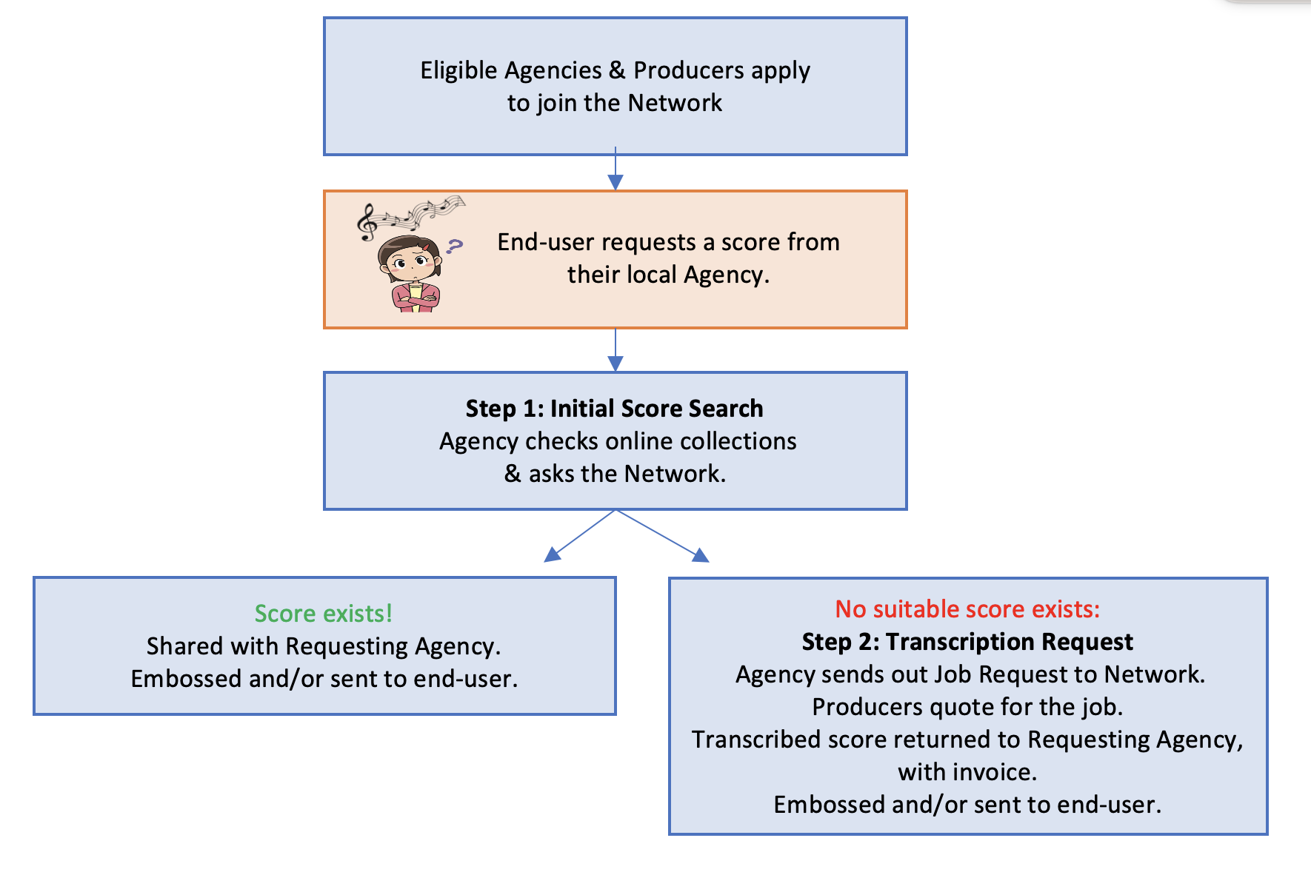

Eligible Agencies and music braille Producers join the Network.

End-user requests a score from their local agency.

If the agency cannot fulfil the request themselves, the agency can contact the Network in two steps to Request the score:

1. **Initial Score Search:**The Requesting Agency checks to see if a suitable score already exists, in online collections and by asking the Network. Network members respond with details of what they have, and share suitable files with the Requesting Agency. The Requesting Agency embosses the score and/or sends it to the end-user.
2. **Transcription Request (if no suitable score exists):**If no suitable score is available, the Requesting Agency completes and sends out a detailed Job Request form to the Network. Producers respond with a quote for doing the transcription. Work can be described as ‘Standard’ or ‘Advanced’ to indicate the level of complexity of the transcription. The Producer will charge their own transcription rate per print page for a ‘Standard’ or ‘Advanced’ job. The final score will be returned by the selected Producer to the Requesting Agency, who embosses the score and/or sends it to the end-user.

# The process in detail

This section describes how the DAISY Music Braille Production Network (MBPN) works in practice, from initial registration of agencies and producers, through to delivery of the required score.

There are two stages of the process, firstly to find if an existing score already exists, and if not, secondly, requesting the score to be produced by one of the producers in the network.

The following graphical flowchart and textual flowchart describe each of these stages in detail.

## Graphical flowchart (textual version follows)

Graphical flowchart

## Textual Flowchart

0.1. Producers and Requesting Agencies apply to join the network by emailing musicbraille@daisy.org and completing a Registration Form. (The Network is not open to members of the public.)

0.2. End-user requests a score from their local Agency.

### Step 1: Initial Score Search

1.1. The Requesting Agency checks online collections, and sends Score Request email to [mbpn@daisylists.org](mailto:mbpn@daisylists.org) asking if anyone has the score available in any format.

IF SCORE AVAILABLE:

1.2. If any member has the score to share, they reply to [mbpn@daisylists.org](mailto:mbpn@daisylists.org), giving details of their holding and cost (if any).

1.3. The Requesting Agency accepts the offer of an existing score from one (or more) members.

1.4. The member sends the file to the Requesting Agency (or direct to the End-User if specified by the Requesting Agency), and seeks payment if there is a charge for the score.

1.5. The Requesting Agency sends the file/embossed copy to the End-User (if not already done), pays any charge for the file, seeks user feedback, and shares relevant feedback with Network/Member providing the score.

IF NO EXISTING SCORE AVAILABLE CONTINUE TO STEP 2:

### Step 2: Transcription Request (if no suitable score is located)

2.1. The Requesting Agency liaises with End-User to complete the Job Request email.

The Requesting Agency sources score/prepares files to send with Job Request and confirms number of print pages; OR asks Producers to source/create score.

2.2. The Requesting Agency sends Job Request to [mbpn@daisylists.org](mailto:mbpn@daisylists.org) (with any source files attached in a zip file) confirming that a suitable score could not previously be located.

Asks Producers to quote for the job.

2.3. Producers review Job Request and if they can do the job by the deadline, they send a quotation to [mbpn@daisylists.org](mailto:mbpn@daisylists.org) (or direct to Requesting Agency if preferred), confirming the job as ‘Standard’/‘Advanced’, cost, and payment terms.

2.4. The Requesting Agency reviews quotes received from Producers, and selects one to do the job, and thanks the others, by emailing [mpbn@daisylists.org](mailto:mpbn@daisylists.org).

2.5. The Selected Producer double-checks that the work is not already available, then fulfils the Job Request in liaison with Requesting Agency and/or End-User.

Producer sends hard-copy and/or digital file to Requesting Agency (or to the End-User) as per Job Request.

2.6. If appropriate, the Requesting Agency adds the file to an online collection & does  
any required copyright reporting. Or, if specified in the Job Request, the Producer does this on their behalf.

2.7a. Producer invoices Requesting Agency as per payment terms.

2.7b. Requesting Agency seeks user feedback and shares relevant feedback with Network/Producer.

# Standard vs Advanced score production

The following descriptors give examples of how a Producer may estimate the complexity of a particular Job Request when making their quote.

Producers charge their own local prices, and depending on the producer, the per-print-page price for an Advanced transcription may be more than for a Standard transcription.

## Standard Service: a score requires standard time, skills and tools to produce in braille

* Producing Agency sources an existing quality MusicXML or similar master, which requires standard transcription, but does not require any scanning, or only minimal mark-up.
* The file contains only vocal/instrumental music with simple notation.
* File is converted using a conversion tool, or manual transcription.
* One proofread is sufficient.
* A digital file of unformatted braille (BRF) is returned to Requesting Agency.

## Advanced Service: a score requires more complex skills, more time and more tools to produce in braille

* Producing Agency can source/use an existing quality MusicXML or similar master; or has to create and/or mark-up a quality source file, which might mean: checking and correcting a MusicXML file; or creating a master by scanning and marking up a print copy; or having the score engraved into a music notation editor following our guidance and exported into MusicXML.
* Transcription may be complex because of the nature of the score, e.g. multiple parts, complex notation, or might be a music text book, with musical examples interspersed with literary text, and/or have footnotes, instructional text etc.
* File is converted using a conversion tool, or manual transcription.
* Two or more proofreading stages are needed, one against the original.
* An unformatted (BRF) and/or formatted (PEF) digital braille file, and/or an embossed copy are returned to the Requesting Agency.

## Comparison Table for Service Levels

|  |  |  |
| --- | --- | --- |
| **Service may include:** | **Standard Service** | **Advanced Service** |
| Sourcing a high-quality score | Yes | Yes |
| Marking-up a MusicXML score | No/minimal | Yes |
| Scanning and marking-up a print score | No | Yes |
| Engraving and exporting score into MusicXML | No | Yes |
| Type of score | Music scores only | Music scores and textbooks |
| Complexity of score | Simple vocal / instrumental | Simple / multiple parts / complex notation |
| Kind of transcription | Manual or automated | Manual or automated, may require special formatting, e.g. Table of Contents/Cross-referencing between volumes, handling of footnotes etc |
| Proofreading | 1 proofread | 2 or more proofreads |
| Result | Unformatted digital braille file only (BRF) | Unformatted (BRF), and/or formatted (PEF) Digital braille file and/or embossed braille copy |

# Other essential documents for Network members

Also available from the Network homepage at <https://daisy.org/mbpn>

## Guidance for producing scores for international use

In order that international users can more easily read scores produced through the Network, the producers have agreed that they are willing to produce scores using commonly agreed requirements. Common formatting also permits easier ingestion into online collections such as the ABC Global Book Service. Our guidance presents our agreed recommendations for preparing scores for international readership.

## Metadata guidance for cataloguers for music braille files

All cataloguers are encouraged to follow these agreed metadata guidelines. This will facilitate international sharing of digital braille music files and support effective search and retrieval from online collections of braille music so that users can find the materials they need and avoid duplicating transcription efforts.

## Good practice guidance for music engravers

If you need scores to be created in a music notation tool and exported as MusicXML before they can be translated into braille, our guidance for music engravers is proven to help them to create a ‘braille-friendly’ master file for us.

The Network also has connections with ‘trusted engravers’ who are experienced at preparing scores for conversion into braille. You can ask the Network for their contact details.

## Standardized emails and order forms

Requesting Agencies are encouraged to use our standardized emails and order form when seeking existing scores, or requesting new jobs. They help you to specify the information the Producer needs to fulfil your request.

## ABC Global Book Service

The ABC Global Book Service is an on-line catalogue (at <https://www.accessiblebooksconsortium.org/web/abc/globalbooks>) which allows participating libraries for the blind and organizations serving people who are print disabled, known as Authorized Entities, to obtain easily the accessible content they need.  The Service supports the goals of the [Marrakesh VIP Treaty](https://www.wipo.int/marrakesh_treaty/en/) at a practical level. All producers are encouraged to add their scores to the ABC Global Book Service so that agencies have the widest access to available scores for their patrons.

# Email templates

This section gives the standardized text for email templates to use when emailing the Music Braille Production Network, so that the necessary information is given in a standard form in each request, for

1. the initial score search, and
2. the transcription request (if no suitable score is located).

## STEP 1 – Initial score search

**1.1) From Requesting Agency**

**To:** [**mbpn@daisylists.org**](mailto:mbpn@daisylists.org)

**Subject**: Seeking [ADD SCORE TITLE(S) and COMPOSERS]

Dear Producers,

If anyone has the following in any format already and can share it with us, please let us know by

**Deadline**: *[add date for replies to be received]*

* **Score/book name**:
* **Composer/Editor**:
* **Publisher, Edition**:

*[Repeat for each score in the request]*

Thanks,

**Name**: *[your name]*

**Email**: *[your email address]*

**Phone:** *[your number, including country code]*

**Agency**: *[your organisation]*

**Country**: *[your country]*

**1.2) From: Responding Producer**

**To:** [**mbpn@daisylists.org**](mailto:mbpn@daisylists.org)

**Subject: Re: Seeking *[SCORE TITLE(S) and COMPOSERS]***

Dear *[Requesting Agency name],*

We can confirm that we have the following:

**Score/book name**:

**Composer/Editor**:

**Publisher, Edition**:

**Details of our holding (e.g. file type, formatting, braille encoding, whole score/excerpt et*c):*** *[add details here]*

*[Repeat for each score you have from their request]*

If you’d like us to provide the file, or send you further information, please let me know:

**Name**: *[your name]*

**Email**: *[your email address]*

**Phone:** *[your number, including country code]*

**Agency**: *[your organisation]*

**Country**: *[your country]*

## STEP 2 - Transcription Request (if no suitable score is located)

**2.1) From: Requesting Agency**

**To:** [**mbpn@daisylists.org**](mailto:mbpn@daisylists.org)

**Subject**: Job Request [ADD SCORE TITLE(S) and COMPOSERS]

Dear Producers,

We couldn’t find a suitable existing score, so now we’re looking for Producers who could quote for doing the production of the following please:

**\*1. About us, the Requesting Agency**

**First name, last name:**

**Organisation:**

**Country:**

**Contact email address:**

**Contact phone:**

**\*2. Job details**

**Order reference number**:

**Deadline for quotes from Producers**:

**Deadline for return of converted score**:

**\*3. Score details**  
*[Repeat sections 3) and 4) for each score in your Order]*

1. **Score/book name**:
2. **Composer/Editor**:
3. **Publisher, Edition**:
4. **Score type required**:
5. **How much of the score is required (All parts / Extract, please specify what):**
6. **Number of print pages required from the score (if known):**
7. **Summary of the request and intended use of the braille score:**

**\* 4. Source file details**

*[Repeat sections 3) and 4) for each score in your Order]*

1. **I am supplying the source?**Yes / No
2. **The source is (e.g PDF, MusicXML, Sibelius etc):**
3. **Origin of source file:**
4. **Quality of source file (if known):**

**\*5. Country Code and Formatting**

* **Country code required** (e.g. US BRF, UTF-8, UEB, Spanish etc):
* **Braille formatting required** (e.g. Section by Section, Bar over Bar):
* **Braille settings for the language specified above** (e.g. lyrics contracted or uncontracted):
* **Braille settings for other languages found in the score** (e.g. lyrics contracted or uncontracted in foreign languages):

**\*6. Output**

**How the score is to be read by the end-user:**braille display / embossed / braille display and embossed

**Output format required\***(delete any which do not apply):

Embossed hard-copy

BRF (formatted text file for embossing/reading on a braille display)

MIDI (audio file, if it can be created from the source file)

PEF (formatted print-ready file for PEF printers)

TXT (unformatted text file for reading on a braille display)

**Page setup (for embossed scores) as cells per line, lines per page (default = 40 cells per line, 25 lines per page):**

**If a music textbook, how you wish it to be presented:**integrated text & music together / in separate volumes of text and of music / please advise

**How much proofreading do you require**: 1 / >1 / please advise

**\*7. Additional information**

**Any further instructions/special requests:**

**\*8. Send your Job Request**

Privacy Statement: By sending this email to [**mbpn@daisylists.org**](mailto:mbpn@daisylists.org)you agree for these details to be shared with Producers in the Network to provide a quote for this job. Your details will not be added to any mailing lists, sold, or used for any other purposes.

**Send this now to**[**mbpn@daisylists.org**](mailto:mbpn@daisylists.org) to go out immediately to all the Producers in the network.

**2.2) From: Production Agency**

**To:** [**mbpn@daisylists.org**](mailto:mbpn@daisylists.org)

**Subject**: Re: Job Request [ADD SCORE TITLE(S) and COMPOSERS]

Dear *[Requesting Agency name],*

We confirm that we can fulfil your Job Request and meet your deadline, and would charge:

**Our Standard Rate / Advanced Rate** *[delete one]* **for this work, totalling:** *[insert amount].*

**Comments:** *[add any other information you’d like to give to the Requesting Agency]*

[*Repeat for each score in the job if they would be charged at different rates].*

**Our payment terms are:** *[insert your payment terms here]*

We look forward to hearing whether we can help you on this occasion.

**Name**: *[your name]*

**Email**: *[your email address]*

**Phone:** *[your number, including country code]*

**Agency**: *[your organisation]*

**Country**: *[your country]*

**2.3) From: Requesting Agency**

**To:** [**mbpn@daisylists.org**](mailto:mbpn@daisylists.org)

**Subject**: Re: Job Request [ADD SCORE TITLE(S) and COMPOSERS]

Dear *[Producer Name],*

We would like to accept your quote for production of this Job Request. Please let us know if you need any further information from us in order to fulfil this order.

Thank you to other producers who may also have quoted for this work, but we do not need your help on this occasion.

Many thanks,

**Name**: [your name]

**Phone:** [your number]

**Agency**: [your organisation]

**Email**: [your email address]