Metadata Guidelines for Braille Music Scores and Music Books

from the DAISY Music Braille Project

Authors: Lindsay Conway (Cataloger, Library of Congress), Luc Maumet (Library Sciences Expert, Accessible Books Consortium), and Sarah Morley Wilkins (Project Manager and User Experience Consultant, DAISY Music Braille Project), with contributions from participants in the DAISY Music Braille Project's metadata working group.

Produced for the DAISY Music Braille Project: https://daisy.org/activities/projects/music-braille/

These guidelines are based on the Metadata Requirements created by the Accessible Books Consortium (ABC).

Finalized: 19 February 2023

Contents
Contents 1
Introduction 3
Background 3
Scope and Purpose 3
Summary List of Metadata Elements 5
Definitions 6
CORE ELEMENTS 7
RECOMMENDED ELEMENTS 15
Appendix 1: Resources for Cataloguing 20
Appendix 2: Sample records for braille music resources using MARC 21 and RDA 21
Example 1: Score 21
Example 2: Identifying Partial Transcriptions 27
Example 3: Compilation/Songbook 27
Example 4: Method Book 29
Example 5: Libretto 31
Example 6: Music Textbook 32

Introduction

Background

We undertook this ground-breaking work on music braille metadata because at the start of the DAISY Music Braille Project transcribers were reporting difficulties in finding suitable braille scores for their users in online collections and in agency libraries, often because there was insufficient metadata to distinguish between files, and because scores varied so much in the way they were produced by different agencies.

Because music braille production is such a specialist activity, expertise in the cataloguing of music braille is particularly scarce. Therefore, amongst other activities, the project devised complementary and collaborative strategic interventions to improve this particular situation:

- To establish core and recommended metadata fields for music braille records which would permit more effective search and retrieval of suitable files in online collections; and
- To create good practice guidance for producers of music braille so that files they produce are more consistent and more easily readable by overseas audiences.

We anticipate that as more and more agencies use these principles to produce and catalogue their scores, agencies will be able to more easily find an increasing number of suitable scores for their end-users.

Scope and Purpose
- Document Purpose: To provide metadata guidelines that facilitate international sharing of digital braille music files and support effective search and retrieval from online collections of braille music so that users can find the materials they need and avoid duplicating transcription efforts.
- These guidelines are intended for use when an organization is cataloguing newly-acquired braille music resources. These guidelines are not intended for retrospective application to an organization's existing catalogue records for resources acquired in the past.
- These guidelines are intended for full and partial transcriptions of braille music resources that have a high likelihood of being used by other braille music readers and being shared with other organizations and institutions via a shared online catalogue.
- This document identifies certain metadata elements as Core (i.e., essential to describing braille music and facilitating sharing of bibliographic data) and others as Recommended (i.e., metadata that should be included whenever available and applicable in order to facilitate international sharing of braille music and enhance searching for braille music scores). The purpose of designating elements as Core is to ensure that braille music readers, transcribers, intermediaries (such as librarians), and other stakeholders have the essential information they need in order to locate, share, and use braille music resources in the environment of international exchange created by the Marrakesh Treaty.
- This document recommends that the Core Elements be present in catalogue records that an organization creates for newly-acquired braille music resources. Each organization that uses this document will decide whether they will encode these elements in MARC 21, adhere to the RDA content standard, and make use of established controlled vocabularies. Using well-established standards for metadata content, encoding, and values is strongly recommended, as doing so will greatly enhance an organization's ability to share its metadata (and consequently its braille music resources) with international partners.
- Appendix 1 provides references to best practices and standards, including RDA and MARC 21, for those organizations that are using these standards or would like to begin implementing them. These guidelines intend to respect local cataloguing standards and practices and do not seek to impose any particular standard or practice on the organizations that wish to use this document.
- The "MARC 21 Suggested Encoding" provided in this document is intended to provide guidance to organizations that are currently using MARC 21 or wish to implement it. This suggested encoding acknowledges and respects that local practices may differ, and it is not intended to impose a mandate or requirement.

Summary List of Metadata Elements

CORE Elements  C1 Local Identifier  C2 Title Information  C3 Author or Composer  C4 Contributor  C5 Music Braille Format  C6 Music Braille Designation  C7 Language  C8 Standard Identifiers  C9 Publisher Information  C10 Production Information  C11 Medium of Performance  C12 File Format  C13 Extent  C14 Type of Braille Encoding  C15 Line length and page length | RECOMMENDED Elements  R1 Contents  R2 Audience(s)  R3 Subject Heading(s)  R4 Genre/Form  R5 File Size  R6 Summary  R7 Braille Language(s) and Contraction(s)  R8 Accessibility Content  R9 Accompanying Matter

Definitions

Core Elements: Metadata that are considered essential to effective bibliographic description of braille music resources and to efficient sharing of bibliographic data among interested parties. These elements should be included in a catalog record whenever they are available and to the utmost extent possible.

Recommended Elements: Metadata that are strongly recommended for inclusion in catalog records whenever they are available and an organization has the resources to provide the information. Providing these elements facilitates international sharing of music braille and greatly enhances search and discovery of music braille scores.

Non-Accessible Publication: The “parent title” or an edition of the work that was originally distributed, printed, or published in a non-accessible format.

Accessible Reproduction: A copy of the parent title in an accessible format.

CORE ELEMENTS

The following metadata elements are considered CORE and therefore essential to bibliographic description and sharing of bibliographic data. Core elements should be included in a catalog record whenever they are available and to the utmost extent possible.

# | CORE Element | Description | Detail | Property | MARC 21 Suggested Encoding
C1 | Local Identifier | A unique identification number used to unambiguously reference an accessible reproduction. |  |  | MARC 001, 016, or 035 may be used.
C2 | Title Information | The title of the braille music resource. | Note on partial transcriptions: A braille music resource that is a partial transcription of the non-accessible publication should be clearly identified as a partial transcription. Examples include: a braille transcription of one movement of a piano sonata that was originally published in its entirety; or a braille transcription of only the soloist part of a concerto that was originally published in its entirety. Such partial transcriptions should be clearly identified to users in the MARC 240, 245, 250, 500 and/or 520 field(s). | Shared element between the non-accessible publication and accessible reproduction | - MARC 245 (to transcribe the title as it appears on the resource itself).  - MARC 246 (for other common titles by which a work may be known to users).  - MARC 240 (where applicable, use 240 for the uniform title of the resource, if available from the Library of Congress Name Authority File). The Library of Congress Name Authority File may be searched using the Library of Congress Linked Data Service: https://id.loc.gov/ or in MARC format on the Library of Congress Authorities website: https://authorities.loc.gov/webvoy.htm
C3 | Author or Composer | The author, composer, or other credited creator of the resource. The author or composer is the person or entity responsible for the content.  Please also provide information for corporate authors (i.e., company names, name of an organization, name of a club or society, government department), and meeting names, when applicable. |  | Shared bibliographic element between the non-accessible publication and accessible reproduction | Using the authorized form of name for the author or composer is strongly recommended, when available. Use MARC 100 for the authorized form of a personal name. Use MARC 110 for the authorized form of a corporate name. The Library of Congress Name Authority File is searchable using the Library of Congress Linked Data Service: https://id.loc.gov/ or on the Library of Congress Authorities website: https://authorities.loc.gov/webvoy.htm  Use MARC 245 $c to record the statement of responsibility as it appears on the resource itself (usually the title page).
C4 | Contributor | Please use the “contributor” field to provide information for the following, whenever applicable: editor, arranger, braille music transcriber, compiler, lyricist, librettist, etc. | If the contributors’ roles (for example, editor, braille music transcriber, etc.) are available, please include them. | Some contributors will be shared between the non-accessible publication and accessible reproduction. Other contributors (such as braille music transcriber) are specific to the accessible reproduction. | Authorized forms of contributor names may be recorded in MARC 700 (personal names) and MARC 710 (corporate bodies). Whenever available, the contributor's role should be specified in $e. The MARC Relators List is available from the Library of Congress Linked Data Service (https://id.loc.gov/). The Library of Congress Name Authority File may be searched using the Library of Congress Linked Data Service: https://id.loc.gov/ or on the Library of Congress Authorities website: https://authorities.loc.gov/webvoy.htm
C5 | Music Braille Format | The method(s) by which print music has been transcribed into braille music notation, or the layout of the braille music notation. | Record as many formats as apply to the transcription. A transcriber may use multiple formats in a braille music transcription. The following are possible braille music formats: Bar over bar, Bar by bar, Line over line, Chord diagrams, Paragraph, Single line, Section by section, Line by line, Open score, Spanner short form scoring, Short form scoring, Outline, Vertical score, Unknown, or Other. | Specific to the accessible reproduction | Use MARC 340 $k to record the braille music format(s) present in a resource. Use terms from the RDA Layout vocabulary (available here: https://www.rdaregistry.info/termList/layout/). Repeat $k as needed to specify all braille music formats in the resource.  For clear display to users, it is also recommended to record the braille music format(s) in a 500 note (546 $b or 520 could also be used).  It is also recommended to record braille music format in MARC 007 f/06-08 (Braille music format character codes in the 007 f--Physical Description Fixed Field for Tactile Material). Up to 3 braille music formats may be specified. For more information about MARC 007--Tactile Material, please refer to: https://www.loc.gov/marc/bibliographic/bd007f.html
C6 | Music Braille Designation | The resource should be clearly identified as containing music braille code. |  | Specific to the accessible reproduction | Use 348 $c to specify the Form of Musical Notation used in the resource. It is recommended to use the term "music braille code" from the RDA Form of Tactile Notation vocabulary (https://www.rdaregistry.info/termList/TacNotation/) (Note: At the time of this writing, RDA Form of Musical Notation vocabulary does not currently provide an appropriate term for braille music).  Additionally, use MARC 007 f/03 ("Class of Braille Writing" in the 007 f--Physical Description Fixed Field for Tactile Material) to specify "Music braille."  If using RDA, also record RDA content type in MARC 336 as "tactile notated music."
C7 | Language | Record the language of any sung or spoken text within a score, such as song lyrics. Where applicable, record the language of the linguistic content, as in a libretto, lesson book, or music textbook. If a resource contains only musical notation (no sung or spoken text and no other linguistic content), then specify "no linguistic content" for this element. |  | Shared bibliographic element between the non-accessible publication and accessible reproduction | If a resource consists of linguistic content (as in a lesson book or textbook), or if a musical score contains sung or spoken text (as in vocal music, for example), specify the language(s) in MARC 008/35-37, 041, and 546 $a. Use MARC language codes in 008/35-37 and 041.
C8 | Standard Identifiers | Standard identifier(s) from a formal identification system that uniquely identifies the non-accessible publication (or “parent” title) from which the accessible reproduction was produced. Examples include ISBN, ISMN, EAN, or music publisher number. Provide all standard identifiers that are available. | Not all music scores have a standard identifier assigned to them, or at times this information is not readily available to the cataloger. In these cases, it is understood that standard identifiers will not be included in the metadata for a braille music resource. | Specific to the non-accessible publication from which the accessible format was reproduced. | ISBN of the non-accessible publication may be recorded in 534 $z. Other identifiers for the non-accessible publication may be recorded in 534 $o.
C9 | Publisher Information | Publisher information relevant to the non-accessible document (or “parent” title) from which the accessible version was reproduced, including: publisher name, city, and year of publication. | Publisher, City of Publication, Year of Publication. | Specific to the non-accessible publication from which the accessible format was reproduced. | MARC 534
C10 | Production Information | Information relevant to the production of the accessible format, including the name of the producer, place of production, and year of production. |  | Specific to the accessible reproduction | MARC 260 or 264. Note that 264 can be repeated multiple times in order to specify and differentiate the entities that may have contributed to producing a music braille score, such as a producer or transcribing agency. Indicator 2 in MARC 264 allows catalogers to specify the function as either: Production, Publication, Distribution, Manufacture, or Copyright notice date. See https://www.loc.gov/marc/bibliographic/bd264.html for more information.
C11 | Medium of Performance | The instrument(s) or voice(s) required to play a piece of music. This information is vital to users who are looking for music for a specific instrument, voice, or ensemble. |  | Shared bibliographic element between the non-accessible publication and accessible reproduction | Encode medium of performance in MARC 382. Library of Congress Medium of Performance Thesaurus (LCMPT) is recommended for use in MARC 382. For more information, see the Music Library Association's Best Practices for Using LCMPT: http://cmc.blog.musiclibraryassoc.org/documents/best-practices-for-using-lcmpt/  As a suggested best practice, if the medium of performance is not clear from the title of the resource in MARC 245, then state the medium of performance in a 500 or 520 note.
C12 | File Format | Where applicable, specify the format of the digital music braille file, such as Duxbury print format (DXP), Duxbury Braille format (DXB), Braille ready format (BRF), BRA, Portable Embosser Format (PEF), Music XML, or MNX, etc. |  | Specific to the accessible reproduction in digital format | MARC 347 $a can be used in conjunction with RDA File Type vocabulary, where appropriate. For example, for a BRF:  347 ## $a text file $2 rdaft
C13 | Extent | Total number of braille volumes and the total number of braille pages that comprise a resource. |  | Specific to the accessible reproduction | MARC 300 $a  Example:  300 __ $a 1 online resource (1 score (1 volume, 36 pages of music braille))
C14 | Type of Braille Encoding | The schema or standard used to encode the content of a digital braille music file. Possible encoding types include North American ASCII braille, European ASCII braille, and Unicode Braille Patterns. |  | Specific to the accessible reproduction in digital format | MARC 347 $b  Example:  347 ## $b BRF (North American ASCII braille)
C15 | Line length and page length | The maximum number of braille cells on each line and maximum number of lines per page is important for users to know if they wish to emboss a file or read it on a braille display. |  | Specific to the accessible reproduction | MARC 340 $b (Physical Medium--Dimensions)  Example: 340 __ $b 40 braille cells per line, 25 lines per page.

RECOMMENDED ELEMENTS

Including the following Recommended Elements in local catalog records is strongly recommended whenever they are available and an organization has the resources to provide the information. Including the following elements greatly improves the quality of information available to organizations around the world that seek to share their collections of braille music. Providing these elements facilitates international sharing of music braille and greatly enhances search and discovery of music braille scores.

 | Recommended Element | Description | Detail | Property | MARC 21 Suggested Encoding
R1 | Contents | Whenever possible, specify the contents of a songbook or other compilation so that they will be searchable and users will be able to locate an individual piece or song contained within the compilation. Excluding the listing of contents means these will be invisible to users. |  | Shared bibliographic element between non-accessible publication and accessible reproduction | MARC 505  For examples, please refer to: https://www.oclc.org/bibformats/en/5xx/505.html
R2 | Audience(s) | A class for whom the accessible reproduction is intended. This includes information that identifies the intended audience for the content. In the case of music braille materials, indicating intended audience will be most helpful in the case of educational materials, such as lesson books, especially specifying the level of difficulty (beginner, intermediate, advanced, etc). |  | Shared bibliographic element between the non-accessible publication and accessible reproduction | MARC fields 385 and 521 may be used for audience information. Library of Congress Demographic Group Terms (LCDGT) Manual is recommended for use in MARC 385: https://www.loc.gov/aba/publications/FreeLCDGT/freelcdgt.html  For examples, please refer to https://www.loc.gov/marc/bibliographic/bd521.html and https://www.oclc.org/bibformats/en/3xx/385.html  "Target Audience" in MARC 008/22 (Fixed-length data elements) is also available for specifying audience information, assuming that one of the listed terms is appropriate for the resource being cataloged.
R3 | Subject Heading(s) | The subject headings that apply to the accessible version. These can be local subject headings or from a standard such as Dewey Decimal Classification (DDC), Library of Congress Subject Headings (LCSH), and/or FAST (Faceted Application of Subject Terminology). | Other sources of subject headings include:  - Canadian Subject Headings (CSH)  - Répertoire de vedettes-matière (RVM)  - Répertoire d’autorité matière encyclopédique et alphabétique unifié (RAMEAU)  - Topical subject terms in the Gemeinsame Normdatei (GND) | Shared bibliographic element between the non-accessible publication and accessible reproduction | Topical subject headings: MARC 650  Dewey Decimal number: MARC 082
R4 | Genre/Form | Genre/form term(s) applicable to the accessible version. Genre/form terms are intended to specify what a resource is, rather than what it is about (which is the role of topical subject headings, above). Examples of genre/form terms includes "Scores," "Librettos," "Cadenzas," "Ballades," and "Methods (Music)." |  | Shared bibliographic element between non-accessible publication and accessible reproduction | MARC 655. Library of Congress Genre/Form Terms for Library and Archival Materials (LCGFT) are recommended for use in MARC 655. LCGFT may be searched using the Library of Congress Linked Data Service: https://id.loc.gov/. For guidance, refer to the Music Library Association's Best Practices for Using LCGFT for Music Resources.
R5 | File Size | File size of the digital version of a braille music resource, if applicable. | Typically, file size should be specified in megabytes (MB). | Specific to the accessible reproduction in digital format | MARC 347 $c
R6 | Summary | Synopsis or description of the work. |  | Shared bibliographic element between non-accessible publication and accessible reproduction | MARC 520. Providing a 520 note can assist users by providing the most important information about the braille music resource in one location within a catalog record. The following content is recommended: title, medium of performance, composer or author, and braille music format(s).
R7 | Braille Language(s) and Contraction(s) | For titles with substantial literary braille content (such as libretti, method books, textbooks, etc), specify the braille code used (UEB, CBFU, etc) as well as the level of contraction. |  | Specific to the accessible reproduction | MARC 546 $b  Example:  546 $b Contracted Unified English Braille.  Level of contraction should also be recorded in MARC 007/05 f--Physical Description Fixed Field for Tactile Material.
R8 | Accessibility Content | Text describing the accessible format of the score or book. |  | Specific to the accessible reproduction | Accessible format details may be recorded in MARC 341 and 532. For 341, consider using LCGFT and/or the Accessibility Discoverability Vocabulary published by W3C: https://www.w3.org/2021/a11y-discov-vocab/latest/.
R9 | Accompanying Matter | Note the presence of any significant material that accompanies a score (preface, composer biography, historical background, bibliography, etc) |  | Shared bibliographic element between non-accessible publication and accessible reproduction | MARC 008/24-29 as well as MARC 500 and/or 520

Appendix 1: Resources for Cataloguing
- MARC 21 bibliographic format documentation: https://www.loc.gov/marc/bibliographic/
- Best Practices from the Music Library Association: http://cmc.blog.musiclibraryassoc.org/mla-best-practices/. Provides guidance for applying the Library of Congress Medium of Performance Thesaurus (LCMPT) and Library of Congress Genre/Form Terms (LCGFT).
- Catalogers Learning Workshop (freely available training resources from the Library of Congress): https://www.loc.gov/catworkshop/
- RDA Toolkit: https://www.rdatoolkit.org/
- Library of Congress Linked Data Service: https://id.loc.gov/. ID.LOC.GOV provides both interactive and machine access to commonly used ontologies, controlled vocabularies, and other lists for bibliographic description, including LC Subject Headings (LCSH), LC Medium of Performance Thesaurus (LCMPT), and LC Genre/Form Terms (LCGFT).
- Quick Start Guide for FAST (Faceted Application of Subject Terminology): https://www.oclc.org/content/dam/oclc/fast/FAST-quick-start-guide-2022.pdf
- OCLC Bibliographic Formats and Standards: https://www.oclc.org/bibformats/en.html
- LOC Authorities Search: https://authorities.loc.gov/. Search authority records, including Library of Congress Subject Headings (LCSH) and Library of Congress Name Authority File (LCNAF).
- The Université Laval manages Répertoire de vedettes-matière (RVM), a French equivalent of LCSH plus Canadian Subject Headings. The file also includes French equivalents to three other documents LC Genre/Form, Medium of Performance and Demographic groups: https://rvmweb.bibl.ulaval.ca/rvmweb/contenu/contenu.do?chemin=/renseignements-utiles/decouvrir-le-rvm

Appendix 2: Sample records for braille music resources using MARC 21 and RDA

Example 1: Score

000 02382ccm a2200541 i 450
001 1073247
005 20221007171953.0
006 m o z
007 fb e na n
007 qu
007 cr nn nnnannaa
008 210917s2021 dcuuulu f nn zxx
010 __ $a 2021994186
040 __ $a DLC-B $b eng $e rda $c DLC-B
072 _7 $a DUETMU $2 NBDL
084 __ $a BRM37314 $2 z
100 1_ $a Gottschalk, Louis Moreau, $d 1829-1869, $e composer.
245 10 $a Célèbre tarentelle de L.M. Gottschalk, op. 67, no. 4 $h [music(braille)] : $b arrangée pour 2 pianos, 4 mains / $c L.M. Gottschalk, compositeur ; Sydney Lambert, arrangée ; transcribed into music braille 2020 by Joseph Siford.
246 30 $a Tarentelle, op. 67
260 __ $a Washington, DC : $b National Library Service for the Blind and Print Disabled, Library of Congress, $c 2021.
300 __ $a 1 online resource (1 score (1 volume, 36 pages of music braille))
336 __ $a tactile notated music $b tcm $2 rdacontent
337 __ $a computer $b c $2 rdamedia
338 __ $a online resource $b cr $2 rdacarrier
340 __ $b 40 braille cells per line, 25 lines per page.
340 __ $k bar over bar $2 rdalay
347 __ $a text $2 rdaft
347 __ $b BRF (North American ASCII braille)
348 __ $a score $2 rdafnm
348 __ $b music braille code $2 rdaftn
382 01 $a piano $n 2 $s 2 $2 lcmpt
383 __ $b op. 67
500 __ $a Originally composed for piano and orchestra.
506 __ $a Availability restricted to those meeting the eligibility requirements of the National Library Service for the Blind and Print Disabled, Library of Congress.
520 __ $a Grande tarantelle, op. 67, subtitled "Célèbre Tarentelle," by Louis Moreau Gottschalk. Arranged for two pianos. Bar over bar format.
530 __ $a Also available for download from BARD/Web-Braille as digital braille. $c Users must register with their cooperating library.
534 __ $p Transcription of: $c Paris : Mackar et Noël, [1890].
650 _0 $a Piano music, Arranged.
650 _0 $a Piano music (Pianos (2)).
650 _0 $a Tarantellas $v Piano scores.
655 _7 $a Tarantellas (Music) $2 lcgft
655 _7 $a Piano scores. $2 lcgft
655 _7 $a Scores. $2 lcgft
700 1_ $a Siford, Joseph, $e transcriber.
852 81 $a DLC-B $c BRM37314 $z NLS/BPD
856 41 $u http://hdl.loc.gov/loc.nls/brm.37314v01 $3 Volume 1.
Bibliographic Leader
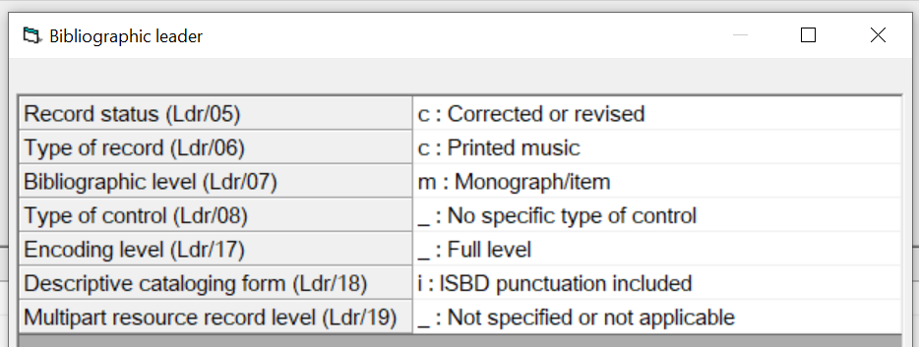

006--Additional Material Characteristics (m--CF/Electronic)
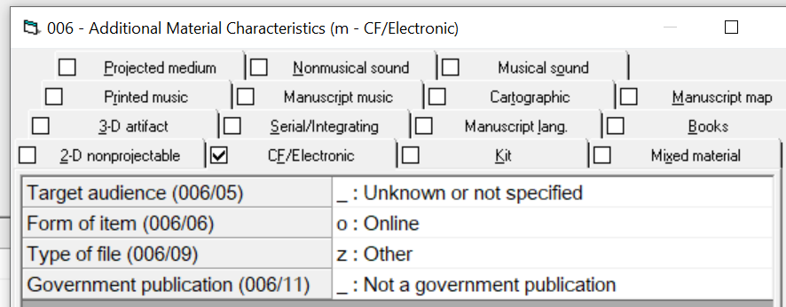

007--Physical Description (q--Notated Music)
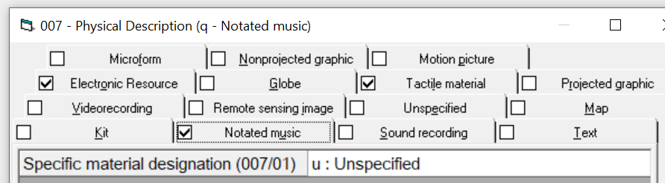

007--Physical Description (f--Tactile Material)
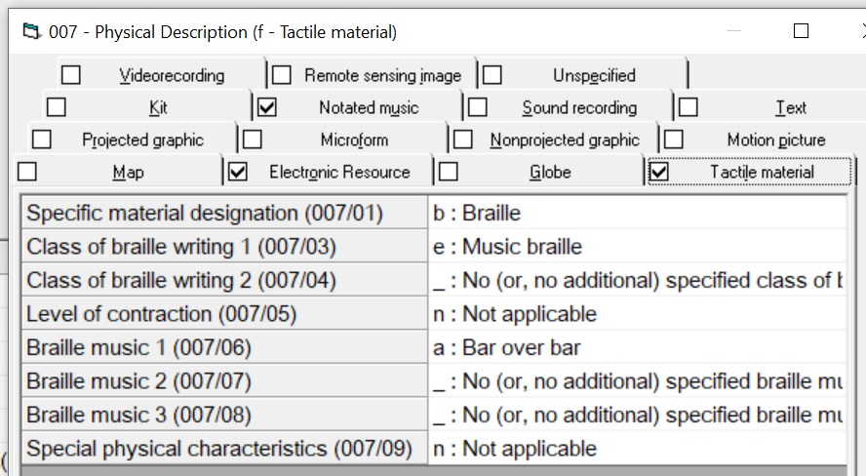

007--Physical Description (c--Electronic Resource)
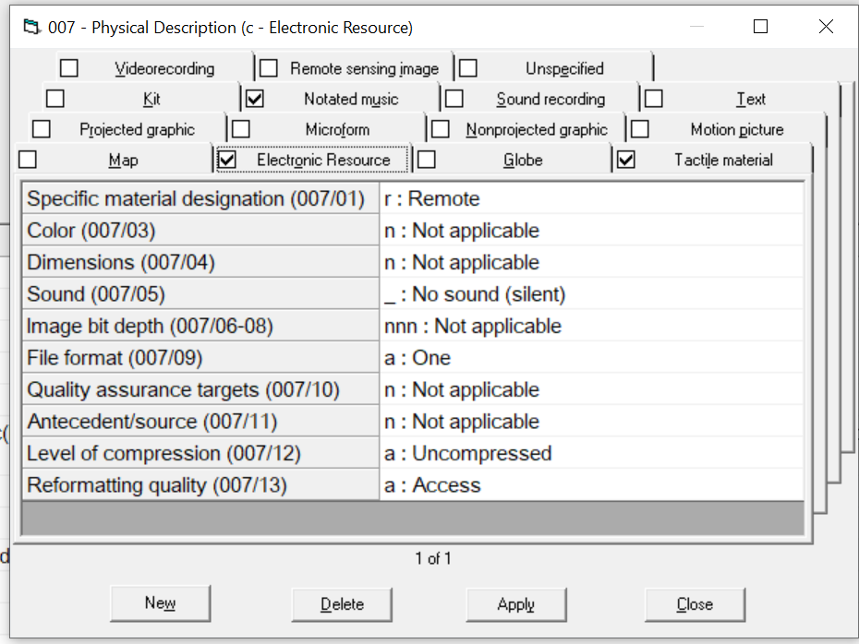

008--General Description (Music)
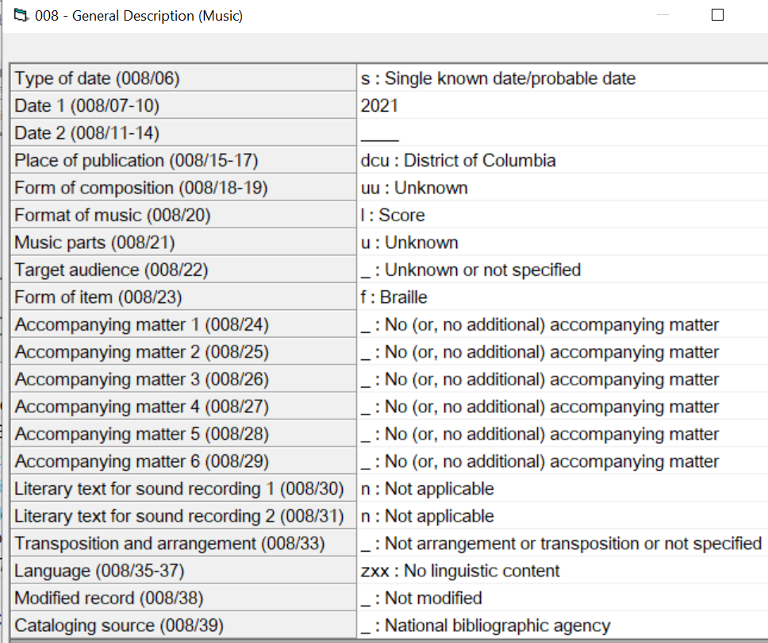

Example 2: Identifying Partial Transcriptions

Several options are available for identifying a braille score as a partial transcription using the MARC and RDA standards. Catalogers may use a combination of MARC fields 240, 245, 250, 500, and/or 520 to accomplish this. When considering these options, what is most important is that catalog users be able to easily identify a partial transcription based on the catalog record.

245
In some cases, the title page of a braille score will make clear that it is a partial transcription. In cases where the title page does not clearly state this, the cataloger may supply this information within brackets in 245 $b in order to aid users with identifying a partial transcription:

245 10 $a Trio in D minor, op. 49 : $b for piano, violin, and violoncello : [violin part only] / $c Felix Mendelssohn-Bartholdy ; edited by Joseph Adamowski.

500 or 520 note
In some cases, a 500 or 520 note may help users identify a partial transcription:

500 _ _ $a Soloist part only.

520 _ _ $a Third movement only (Adagio. Andante) of Serenade no. 10 for winds in B-flat major, K. 361/370a by Wolfgang Amadeus Mozart. Bar over bar format.

240
In some cases, a uniform title may be available to identify a partial transcription. For example, if a print score for the complete Piano Concerto No. 21, K. 467, by Mozart were used to create a braille transcription of only the second movement (Andante), then the following uniform title could be used in the 240 field for the braille transcription:

240 1_ $a Concertos, $m piano, orchestra, $n K. 467, $r C major. $p Andante

250
An edition statement in the 250 field is also an option for identifying a partial transcription. If the braille score itself lacks such an edition statement, then the cataloger may supply one within brackets:

250 _ _ $a [Soloist part]

250 _ _ $a [Soprano chorus part]

250 _ _ $a [Second movement]

Example 3: Compilation/Songbook

000 03851ccm a2200661 i 450
001 1071679
005 20221007172108.0
006 m o z
007 fb eaaga n
007 qu
007 cr nn nnnannaa
008 210901s2021 dcuuulu fab nn eng
010 __ $a 2021994163
040 __ $a DLC-B $b eng $e rda $c DLC-B
041 0_ $a eng
072 _7 $a VOCPMU $2 NBDL
084 __ $a BRM37253 $2 z
245 00 $a Ella Fitzgerald $h [music(braille)] : $b original keys for singers : piano/vocal / $c transcribed in music braille by Robert J. Dietrich.
260 __ $a Washington, DC : $b National Library Service for the Blind and Print Disabled, Library of Congress, $c 2021.
300 __ $a 1 online resource (1 score (4 volumes, 490 pages of music braille))
336 __ $a tactile notated music $b tcm $2 rdacontent
337 __ $a computer $b c $2 rdamedia
338 __ $a online resource $b cr $2 rdacarrier
340 __ $b 40 braille cells per line, 25 lines per page.
340 __ $k bar over bar $k line by line $2 rdalay
347 __ $a text $2 rdaft
347 __ $b BRF (North American ASCII braille)
348 __ $a score $2 rdafnm
348 __ $b music braille code $2 rdaftn
382 01 $a singer $n 1 $a piano $n 1 $s 2 $2 lcmpt
490 1_ $a Original keys for singers
500 __ $a Includes biographical note on Ella Fitzgerald and discography.
505 00 $g Volume 1: $t A-tisket, a-tasket -- $t Black coffee -- $t But not for me -- $t Cheek to cheek -- $t Easy to love (you’d be so easy to love) -- $t Embraceable you -- $t Ev’ry time we say goodbye.
505 00 $g Volume 2: $t How long has this been going on? -- $t I got it bad and that ain’t good -- $t I’m beginning to see the light -- $t I’m putting all my eggs in one basket -- $t I’ve got my love to keep me warm -- $t If you can’t sing it (you’ll have to swing it).
505 00 $g Volume 3: $t Ill wind (you’re blowin’ me no good) -- $t It don’t mean a thing (if it ain’t got that swing) -- $t Just one of those things -- $t The lady is a tramp -- $t Let’s call the whole thing off.
505 00 $g Volume 4: $t Lullaby of Birdland -- $t Midnight sun -- $t Misty -- $t Oh, lady be good! -- $t Satin doll -- $t Stompin’ at the Savoy -- $t Take the "A" train.
506 __ $a Availability restricted to those meeting the eligibility requirements of the National Library Service for the Blind and Print Disabled, Library of Congress.
520 __ $a "This fine book features authentic transcriptions in the original keys of 25 Fitzgerald classics in voice with piano accompaniment format."--Publisher website. Jazz vocals as performed by Ella Fitzgerald, transcribed from recordings. For voice and piano. Includes chord symbols. Line by line and bar over bar formats. For each song, the vocal part is transcribed first, immediately followed by the piano accompaniment. This digital file has been partially proofread. To report errors, please contact the Music Section.
530 __ $a Also available for download from BARD/Web-Braille as digital braille. $c Users must register with their cooperating library.
534 __ $p Transcription of: $c Milwaukee, WI, : Hal Leonard, [2004]. $z 978-0-634-06342-8.
546 __ $a In English.
650 _0 $a Jazz vocals.
650 _0 $a Popular music $v Scores.
650 _0 $a Popular music $v Vocal scores with piano.
655 _7 $a Scores. $2 lcgft
655 _7 $a Popular music. $2 lcgft
655 _7 $a Songs. $2 lcgft
700 1_ $a Dietrich, Robert J., $e transcriber.
700 1_ $a Fitzgerald, Ella, $e singer.
700 1_ $a Mankowski, Forrest, $d 1966- $e transcriber.
830 _0 $a Original keys for singers.
852 81 $a DLC-B $c BRM37253 $z NLS/BPD
856 41 $u http://hdl.loc.gov/loc.nls/brm.37253v01 $3 Volume 1.
856 41 $u http://hdl.loc.gov/loc.nls/brm.37253v02 $3 Volume 2.
856 41 $u http://hdl.loc.gov/loc.nls/brm.37253v03 $3 Volume 3.
856 41 $u http://hdl.loc.gov/loc.nls/brm.37253v04 $3 Volume 4.

Example 4: Method Book

000 03077ccm a2200649 i 450
001 1076259
005 20221007172150.0
006 m o z
007 fb eabea n
007 qu
007 cr nn nnnannaa
008 211105s2021 dcuuulu fr nn eng
010 __ $a 2021994242
040 __ $a DLC-B $b eng $e rda $c DLC-B
041 0_ $a eng
072 _7 $a WINDMU $2 NBDL
072 _7 $a BANDMU $2 NBDL
072 _7 $a INSTMU $2 NBDL
084 __ $a BRM37400 $2 z
100 1_ $a Pearson, Bruce, $d 1942-, $e author, $e compiler.
245 10 $a Tradition of excellence. $n Book 2, $p Flute $h [music(braille)] : $b comprehensive band method / $c by Bruce Pearson and Ryan Nowlin ; transcribed 2021 by Patrick Janson ; edited by Kathleen Cantrell.
250 __ $a Second edition.
260 __ $a Washington, DC : $b National Library Service for the Blind and Print Disabled, Library of Congress, $c 2021.
300 __ $a 1 online resource (1 score (3 volumes, 227 pages of braille music))
336 __ $a tactile notated music $b tcm $2 rdacontent
337 __ $a computer $b c $2 rdamedia
338 __ $a online resource $b cr $2 rdacarrier
347 __ $a text $2 rdaft
347 __ $b BRF (North American ASCII braille)
340 __ $b 40 braille cells per line, 25 lines per page.
340 __ $k single line $k bar over bar $2 rdalay
348 __ $a score $2 rdafnm
348 __ $b music braille code $2 rdaftn
382 01 $a flute $n 1 $s 1 $2 lcmpt
490 0_ $a Tradition of excellence
500 __ $a Single line format and bar over bar format.
506 __ $a Availability restricted to those meeting the eligibility requirements of the National Library Service for the Blind and Print Disabled, Library of Congress.
520 __ $a "Tradition of Excellence by Bruce Pearson and Ryan Nowlin is a comprehensive and innovative curriculum designed to appeal to today’s students. The music...the scope and sequence; the tools for differentiated instruction; the smooth pacing with careful review...make Tradition of Excellence the fastest growing band method today!" --Publisher's note. In single line and bar over bar formats.
530 __ $a Also available for download from BARD/Web-Braille as digital braille. $c Users must register with their cooperating library.
534 __ $p Transcription of: $c San Diego, California : Kjos Music Press, ©2016. $o W62FL, $z 0-8497-7125-0, $z 978-0-8497-7125-5.
546 __ $a In English.
546 __ $b Unified English Braille (contracted).
650 _0 $a Flute $v Methods $v Juvenile.
650 _0 $a Flute $x Instruction and study.
650 _0 $a Bands (Music) $x Instruction and study.
655 _7 $a Methods. (Music) $2 lcgft
655 _7 $a Scores. $2 lcgft
700 1_ $a Janson, Patrick, $e transcriber.
700 1_ $a Cantrell, Kathleen, $e editor.
700 1_ $a Nowlin, Ryan, $e author, $e compiler.
852 81 $a DLC-B $c BRM37400 $z NLS/BPD
856 41 $u http://hdl.loc.gov/loc.nls/brm.37400v01 $3 Volume 1.
856 41 $u http://hdl.loc.gov/loc.nls/brm.37400v02 $3 Volume 2.
856 41 $u http://hdl.loc.gov/loc.nls/brm.37400v03 $3 Volume 3.

Example 5: Libretto

000 02766cam a2200541 i 450
001 717808
005 20220929163037.0
006 m o z
007 cr nn nnnannaa
007 fb a mnnnn
008 110216s2010 dcu gf$$$$ 000 h$fre
010 __ $a 2011991425
040 __ $a DLC-B $b eng $e rda $c DLC-B
041 1_ $e eng $e fre $n fre
072 _7 $a LIBRAN $2 NBDL
084 __ $a BRM35543 $2 z
100 1_ $a Rossini, Gioacchino, $d 1792-1868, $e composer.
240 10 $a Comte Ory (Libretto)
245 13 $a Le Comte Ory $h [braille] $b opera in two acts / $c music by Gioacchino Rossini ; libretto by Eugène Scribe & Charles Gaspard Delestre-Poirson, after a medieval ballad ; English translation by Robert Jordan ; produced in braille by Master Conversions.
246 1_ $a Count Ory
260 __ $a Washington, D.C. : $b National Library Service for the Blind and Print Disabled, Library of Congress, $c 2010. $f (Master Conversions, transcribing agency)
300 __ $a 3 volumes (378 pages of braille).
336 __ $a tactile text $b tct $2 rdacontent
337 __ $a computer $b c $2 rdamedia
338 __ $a online resource $b cr $2 rdacarrier
340 __ $b 40 braille cells per line, 25 lines per page.
347 __ $a text $2 rdaft
347 __ $b BRF (North American ASCII braille)
500 __ $a Volume 1: Libretto in French. Volume 2: Libretto in English. Volume 3: Libretto in French and English.
500 __ $a The libretto and accompanying information was transcribed from the version included in the 1989 Philips Classics recording.
506 __ $a Availability restricted to those meeting the eligibility requirements of the holding agency.
520 __ $a Libretto in the original French as well as English translation by Robert Jordan. It includes the essay, "A World of Disguises and Masquerades" by Philip Gossett and a synopsis of the opera.
530 __ $a Also available from Web Braille as contracted digital braille files. $c Users must register with their cooperating library.
534 __ $p Transcription of: $c London : Philips, 1989, $o Philips 422 406-4.
546 __ $a Libretto in French with English translation.
546 __ $b In contracted English braille and uncontracted French braille.
650 _0 $a Operas $v Librettos.
655 _7 $a Braille books. $2 lcgft
655 _7 $a Librettos. $2 lcgft
700 1_ $a Delestre-Poirson, C.-G. $q (Charles-Gaspard), $d 1790-1859.
700 1_ $a Scribe, Eugène, $d 1791-1861.
852 81 $a DLC-B $c BRM35543 $z NLS/BPD
856 41 $u http://hdl.loc.gov/loc.nls/brm.35543v01 $3 Volume 1.
856 41 $u http://hdl.loc.gov/loc.nls/brm.35543v02 $3 Volume 2.
856 41 $u http://hdl.loc.gov/loc.nls/brm.35543v03 $3 Volume 3.

Example 6: Music Textbook

000 04229cam a2200673 i 450
001 659021
005 20221007172300.0
006 m o z
007 cr nn nnnannaa
007 fb aebagen
008 091016s2008 dcug f 001 0 eng
010 __ $a 2009995196
040 __ $a DLC-B $b eng $e rda $c DLC-B
041 0_ $a eng
072 _7 $a THRYAN $2 NBDL
084 __ $a BRM34962 $2 z
100 1_ $a Kostka, Stefan M., $e author.
245 10 $a Tonal harmony $h [braille] : $b with an introduction to twentieth-century music / $c Stefan Kostka and Dorothy Payne.
250 __ $a Sixth edition.
260 __ $a Washington, D.C. : $b National Library Service for the Blind and Print Disabled, Library of Congress, $c 2008.
300 __ $a 15 volumes of braille.
336 __ $a tactile text $b tct $2 rdacontent
336 __ $a tactile notated music $b tcm $2 rdacontent
337 __ $a computer $b c $2 rdamedia
338 __ $a online resource $b cr $2 rdacarrier
340 __ $b 40 braille cells per line, 25 lines per page
340 __ $k bar over bar $k single line $k line by line $k open score $2 rdalay
347 __ $a text $2 rdaft
347 __ $b BRF (North American ASCII braille)
348 __ $b music braille code $2 rdaftn
500 __ $a Contracted braille, bar over bar, line by line, single line, and open score formats.
500 __ $a Includes indexes.
500 __ $a Accompanying workbook available at BRM34963.
505 0_ $a Fundamentals. Elements of pitch ; Elements of rhythm ; Introduction to triads and seventh chords ; Diatonic chords in major and minor keys -- Diatonic triads. Principles of voice leading ; Root-position part writing ; Harmonic progression and the sequence ; Triads in first inversion ; Triads in second inversion ; Cadences, phrases, periods, and sentences ; Two-part tonal counterpoint ; Nonchord tones 1 ; Nonchord tones 2 -- Diatonic seventh chords. The Vp7s chord ; Other diatonic seventh chords -- Chromaticism 1. Secondary functions 1 ; Secondary functions 2 ; Modulations using diatonic common chords ; Some other modulatory techniques ; Larger forms -- Chromaticism 2. Mode mixture and the Neapolitan ; Augmented sixth chords ; Enharmonic spellings and enharmonic modulations ; Further elements of the harmonic vocabulary ; Tonal harmony in the late nineteenth century -- An introduction to post-tonal music. Materials and techniques ; Post-tonal theory ; New directions -- Appendix A: Instrumental ranges and transpositions -- Appendix B: Lead-sheet symbols -- Appendix C: Set class list -- Appendix D: Answers to self-tests.
506 __ $a Availability restricted to those meeting the eligibility requirements of the holding agency.
520 __ $a Text for AP Music Theory students in high school and college music majors. Contains contracted braille, bar over bar, line by line, single line, and open score formats.
530 __ $a Also available from Web braille as electronic braille music files. $c Users must register with their cooperating library.
534 __ $p Transcription of: $b 6th ed. $c Boston : McGraw-Hill, c2009. $z 0073401358.
546 __ $a In English.
546 __ $b EBAE braille code (contracted).
650 _0 $a Harmony.
655 _4 $a Nonfiction.
655 _7 $a Textbooks. $2 lcgft
655 _7 $a Braille books. $2 lcgft
700 1_ $a Payne, Dorothy, $e author.
852 81 $a DLC-B $c BRM34962 $z NLS/BPD
856 41 $u http://hdl.loc.gov/loc.nls/brm.34962v01 $3 Volume 1.
856 41 $u http://hdl.loc.gov/loc.nls/brm.34962v02 $3 Volume 2.
856 41 $u http://hdl.loc.gov/loc.nls/brm.34962v03 $3 Volume 3.
856 41 $u http://hdl.loc.gov/loc.nls/brm.34962v04 $3 Volume 4.
856 41 $u http://hdl.loc.gov/loc.nls/brm.34962v05 $3 Volume 5.
856 41 $u http://hdl.loc.gov/loc.nls/brm.34962v06 $3 Volume 6.
856 41 $u http://hdl.loc.gov/loc.nls/brm.34962v07 $3 Volume 7.
856 41 $u http://hdl.loc.gov/loc.nls/brm.34962v08 $3 Volume 8.
856 41 $u http://hdl.loc.gov/loc.nls/brm.34962v09 $3 Volume 9.
856 41 $u http://hdl.loc.gov/loc.nls/brm.34962v10 $3 Volume 10.
856 41 $u http://hdl.loc.gov/loc.nls/brm.34962v11 $3 Volume 11.
856 41 $u http://hdl.loc.gov/loc.nls/brm.34962v12 $3 Volume 12.
856 41 $u http://hdl.loc.gov/loc.nls/brm.34962v13 $3 Volume 13.
856 41 $u http://hdl.loc.gov/loc.nls/brm.34962v14 $3 Volume 14.
856 41 $u http://hdl.loc.gov/loc.nls/brm.34962v15 $3 Volume 15.

