A-Z of Accessible Digital Publishing

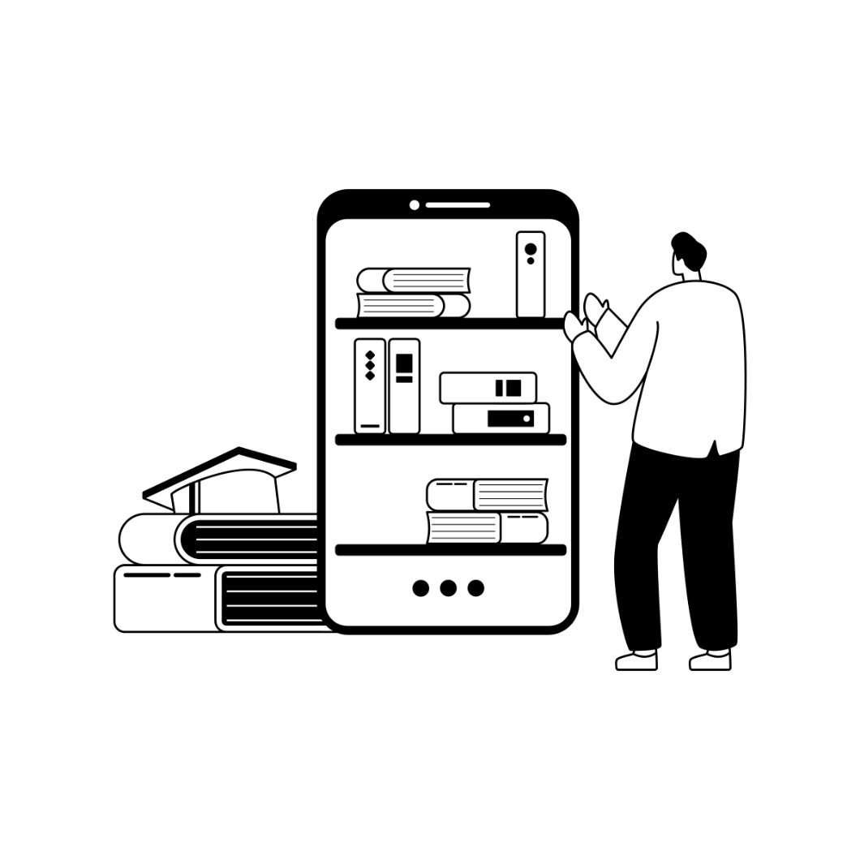

From the DAISY Consortium

A-Z of Accessible Digital Publishing was published 2025 by

The DAISY Consortium.

Copyright © 2025 The DAISY Consortium

Version 1.0

Download the latest version at:

<https://inclusivepublishing.org/gaad>

A-Z of Accessible Digital Publishing is licensed under [CC BY-NC-SA 4.0](https://creativecommons.org/licenses/by-nc-sa/4.0/). This license requires that re-users give credit to the creator. It allows re-users to distribute, remix, adapt, and build upon the material in any medium or format, for noncommercial purposes only. If others modify or adapt the material, they must license the modified material under identical terms.

The DAISY Consortium welcomes your support and collaboration via its [sponsorship initiative](https://inclusivepublishing.org/sponsorship/).

This document is available in: Word and EPUB

[](https://daisy.org/)

# About this Book

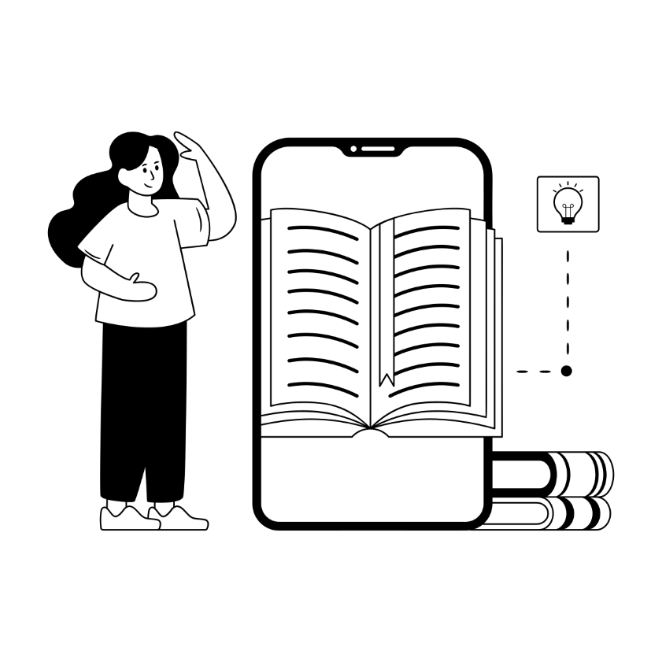

This book has been produced to celebrate [Global Accessibility Awareness Day.](https://accessibility.day/) It was created in MS Word and converted to EPUB3 using [WordToEPUB](https://daisy.org/activities/software/wordtoepub/) and checked for accessibility with [Ace](https://inclusivepublishing.org/toolbox/accessibility-checker/) and [SMART](https://inclusivepublishing.org/toolbox/ace-smart/), all free tools from the DAISY Consortium.

This publication is intended as a fun way to get people talking about accessibility, not a comprehensive resource.

Related Resources

* [DAISY Toolbox](https://inclusivepublishing.org/toolbox/)
* [Getting Started with Accessible Publishing](https://inclusivepublishing.org/publisher/getting-started/)

# Braille Display



A type of assistive technology, braille displays can attach physically or wirelessly to a computer or mobile device to render text as braille in real time. The braille is formed from a set of pins which are raised and lowered to construct the braille cells to be read by touch. Additional buttons on the display enable navigation, allowing someone reading a publication in braille to enjoy the same features as anyone else.

Related Resources

* [Wikipedia Refreshable Braille Display](https://en.wikipedia.org/wiki/Refreshable_braille_display)
* An RNIB Overview of [Braille Displays and Readers](https://www.rnib.org.uk/living-with-sight-loss/assistive-aids-and-technology/reading-and-writing/an-rnib-guide-to-braille-displays-for-blind-and-partially-sighted-people/)

# Color Contrast



A good color contrast ratio is necessary for accessibility particularly for people who have a form of color blindness, low vision or dyslexia. User requirements can vary significantly and affect the readability and inclusivity of content. Color contrast tools can help identify issues in meeting WCAG guidelines and suggest improved values.

Related Resources

* The [Web Content Accessibility Guidelines](https://www.w3.org/WAI/standards-guidelines/wcag/) (WCAG) provide minimum levels for [color contrast ratios](https://www.w3.org/WAI/WCAG22/Understanding/contrast-minimum.html).
* [Accessible Publishing Knowledge Base: Contrast](https://kb.daisy.org/publishing/docs/css/contrast.html)
* [WebAIM’s Contrast Checker](https://webaim.org/resources/contrastchecker/)

# Descriptive Links



Descriptive link text clearly explains where the user will be taken when following the link. Screen reader users often utilize a feature to list all links in a document, so the relevant information needs to be conveyed within the link itself, allowing it to function without the surrounding text.

Related Resources

* [Master the Art of Descriptive Link text](https://www.wcag.com/blog/writing-meaningful-link-text/)
* [Enhancing Accessibility: Link Text Best Practices](https://www.levelaccess.com/blog/enhancing-accessibility-link-text-best-practices/)

# European Accessibility Act



The EAA is a directive that aims to improve access to products and services to consumers within the European Union. This affects many aspects of the publishing ecosystem which includes ebooks, reading systems and the websites of many organizations who sell into the EU market irrespective of their location.

Related Resources

* [EAA Directive](https://eur-lex.europa.eu/legal-content/EN/TXT/?uri=celex%3A32019L0882)
* Inclusive Publishing [EAA Resources page](https://inclusivepublishing.org/inclusive-publishing-hub-resources/eu/)
* [DAISY Countdown to the EAA Webinar Series](https://daisy.org/webinar-series/)

# Fixed Layout



Fixed layout content remains static and does not support adjustments of text size. It tends to be used for highly illustrated content such as children’s books and where the placement of text and graphics is deemed critical. Fixed layout publications, by nature present greater accessibility challenges, restricting the flexible reading essential for some users. Work is being done to provide guidance for some formats, however the most accessible user experience will likely always be one that supports reflowable content.

Related Resources

* W3C Note on [EPUB Fixed Layout Accessibility](https://www.w3.org/TR/epub-fxl-a11y/)
* [Knowledge Base Fixed Layout Overview](https://kb.daisy.org/publishing/docs/fxl/overview.html)

# Guidelines and Training

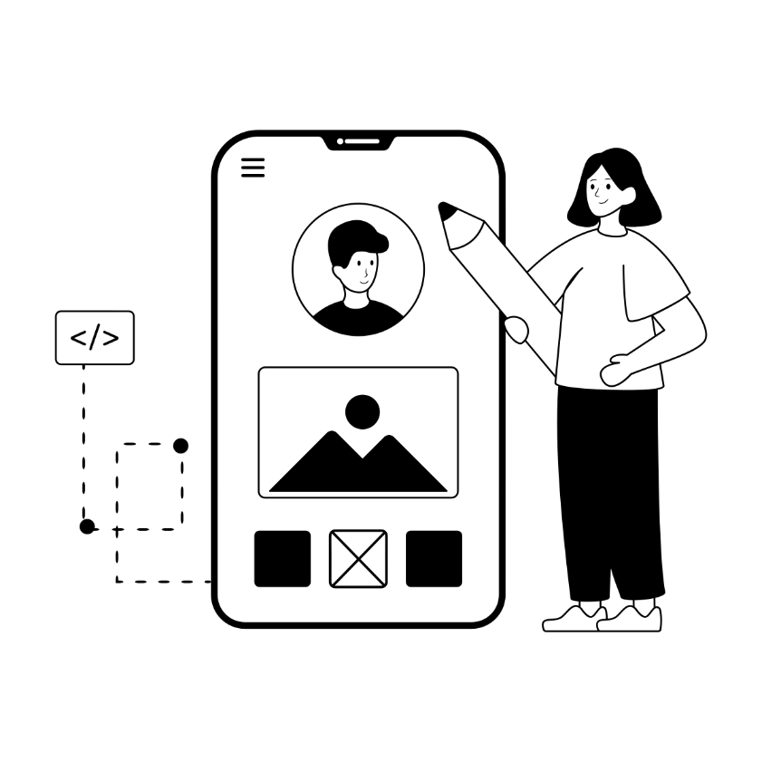

Accessibility is a journey, not a destination. To help ensure you’re on the right path there is a lot of guidance and training available and it is advisable to regularly check guidance and best practices through online training courses and webinars.

Related Resources

* [Inclusive Publishing Training Resource List](https://inclusivepublishing.org/inclusive-publishing-hub-resources/training/)
* [Guidelines and Standards](https://inclusivepublishing.org/publisher/guidance-and-standards-information/)
* [DAISY Webinars](https://daisy.org/webinar-series/)

# Hierarchical Structure



A hierarchical structure within digital content allows for logical navigation throughout the publication. A consistent hierarchy, together with a functional table of contents, provides access to everyone, especially people using a screen reader or other assistive technologies who can list and navigate by heading level.

Related Resources

* [W3C Page Structure Tutorial](https://www.w3.org/WAI/tutorials/page-structure/)
* [Mastering Accessible Headings](https://medium.com/design-domination/mastering-accessible-headings-39e3b402a260)

# Image Description

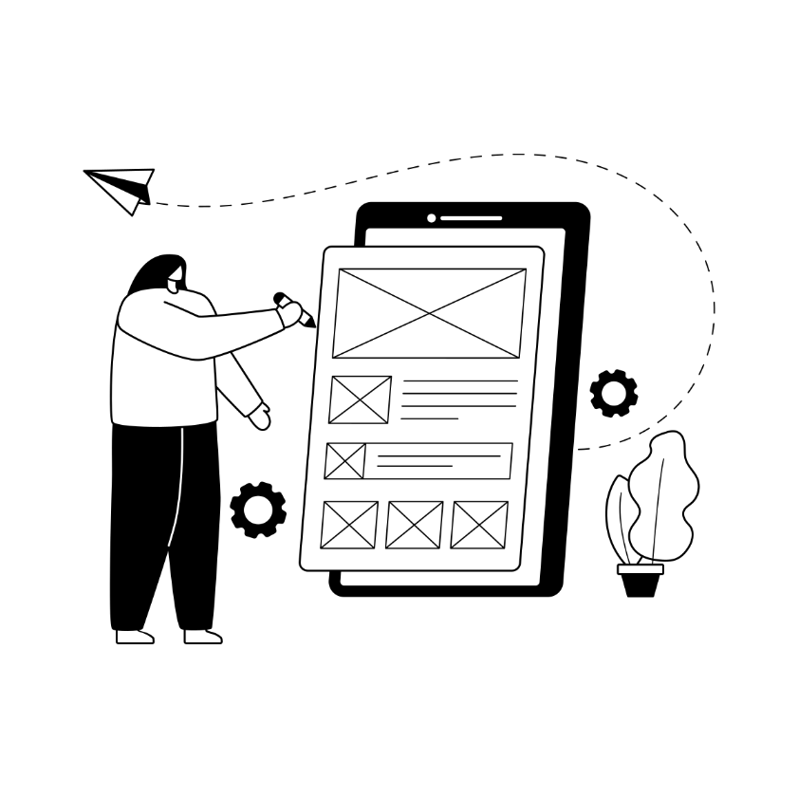

A text based description or explanation of an image or table that can be read by users of assistive technology such as screen reader software. An image description may be a short passage of alt text, or a linked extended description for more complex content.

Related Resources

* DAISY Webinar: [Image Description](https://daisy.org/news-events/articles/image-description-t-269-w/)
* [Rich and Complex Content](https://inclusivepublishing.org/publisher/rich-and-complex-content/)
* [Accessible Publishing Knowledge Base: Image Description](https://kb.daisy.org/publishing/docs/html/images-desc.html)

# Justification



It is often necessary to justify an approach to accessible publishing and having a healthy case prepared can be invaluable. Accessibility is good for business, is often a legal requirement, produces higher quality publications and it is, simply, the right thing to do.

Related Resources

* [The Business Case for Accessible Publishing](https://inclusivepublishing.org/publisher/the-business-case-for-accessible-publishing/)
* [Regional Legal Requirements](https://inclusivepublishing.org/inclusive-publishing-hub-resources/ebook-legislation/)

# Keyboard Shortcuts

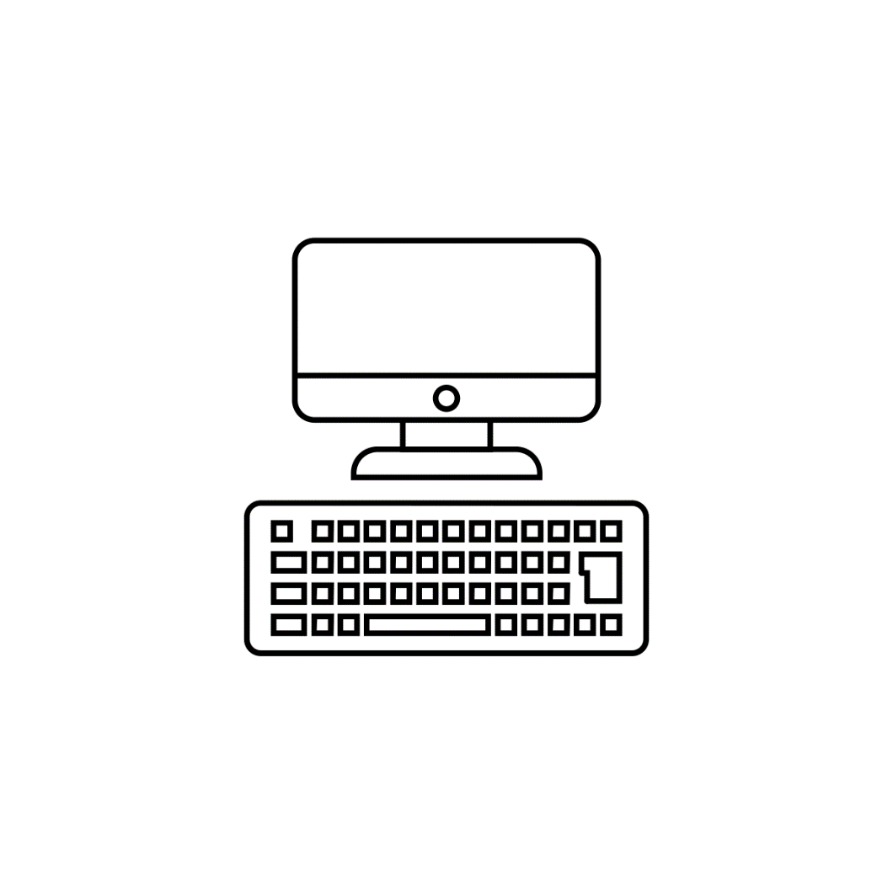

Typically, a combination of keys on a keyboard can provide quick access to a particular function within an application or operating system. Keyboard access and shortcuts are essential for users of assistive technology who operate without a mouse.

Related Resources

* [WebAIM Keyboard Accessibility](https://webaim.org/techniques/keyboard/)
* [Deque University Screen Reader Keyboard Shortcuts and Gestures](https://dequeuniversity.com/screenreaders/)

# Large Print

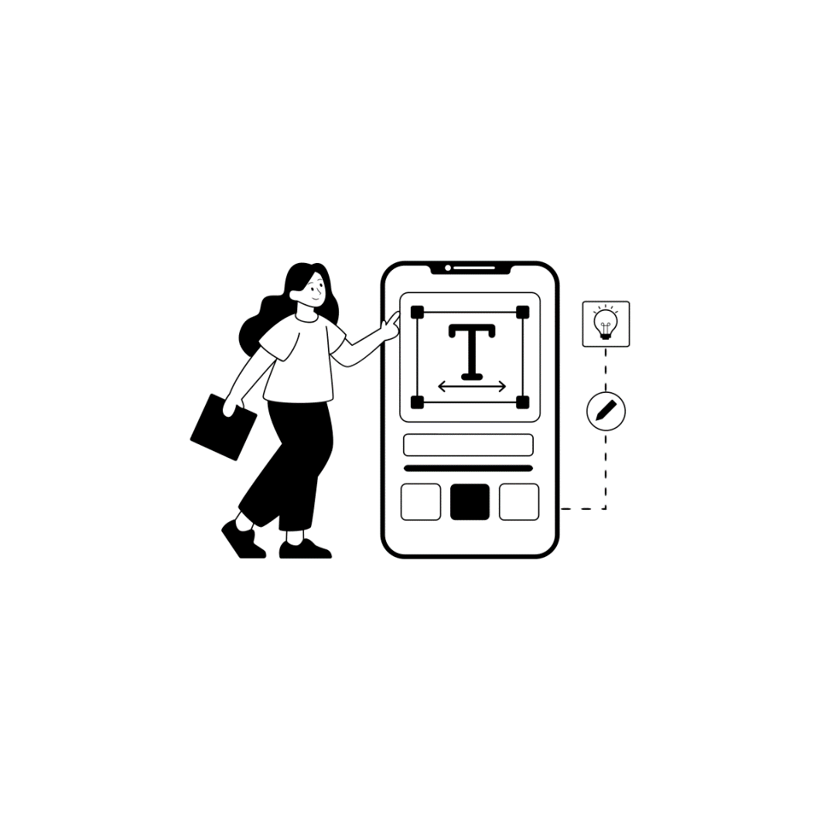

Most people reading text have a preferred range of text sizes that are comfortable for them to read. People with low vision often require larger text, and ebooks designed to be reflowable automatically support dynamic text scaling to make the text usable.

Related Resources

* [RNIB Large and Giant Print](https://www.rnib.org.uk/living-with-sight-loss/independent-living/reading-and-books/large-and-giant-print/)
* [ACB Large Print Guidelines](https://www.acb.org/large-print-guidelines)

# Metadata

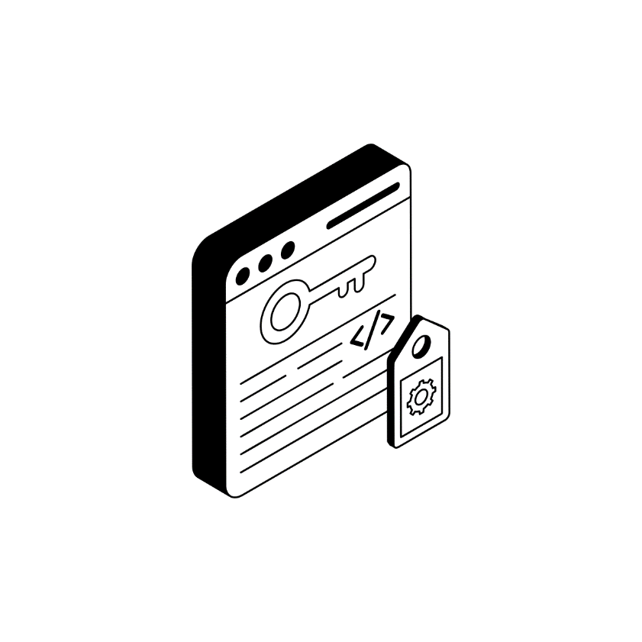

Metadata is essentially digital data that provides information about a publication. ONIX for Books metadata is used for capturing and communicating information to retailers and distributors. ONIX codelist196 is specifically for the accessibility features within the content. Accessibility metadata can also be included in EPUB files via schema.org and publishers should include details so that readers can identify content that is suitable for them.

Related Resources

* DAISY Webinar: [Accessibility Metadata](https://daisy.org/news-events/articles/accessibility-metadata-t-157-w/)
* [Metadata for Digital Publishing Overview](https://inclusivepublishing.org/publisher/metadata/)

# Navigation

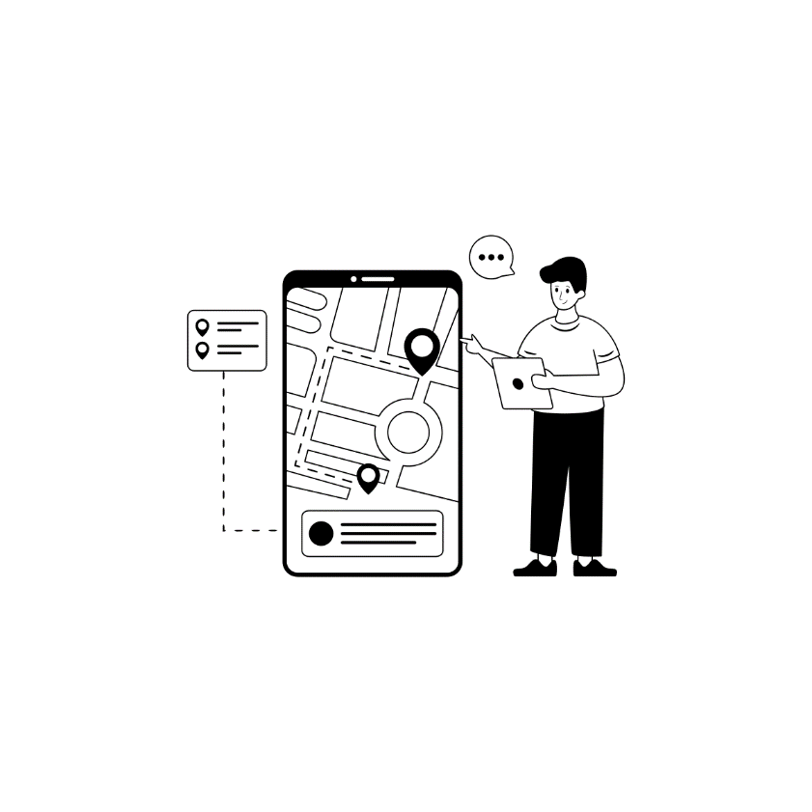

Readers often need to move around within a publication to find a location based on page number or chapter, check a footnote or appendix, or to simply resume reading from their last location. A well-structured ebook and good reading system can facilitate logical navigation and provide all readers, including those using assistive technology, with the ability to access and use a publication in the same way as any other reader.

Good navigation includes a table of contents, logical reading order, meaningful links and page numbers.

Related Resources

* [Accessible Publishing Knowledge Base: Navigation](https://kb.daisy.org/publishing/docs/navigation/)

# Organizational Policy



Organizations should be clear about their approach to accessibility by providing an accessibility policy in-house and online, ideally appointing a person or team responsible for accessibility and providing clear guidance and training.

Related Resources

* DAISY Webinar: [Policy and Practice](https://inclusivepublishing.org/blog/publishing-accessibility-policy-and-practice-t-66-w/)
* [Organizational and Practical Information](https://inclusivepublishing.org/publisher/organisational-and-practical-information/)
* [The ASPIRE verification service for Accessibility Statements](https://www.textboxdigital.com/aspire-home)

# Print Disability



Print Disability is a term coined by DAISY’s George Kerscher describing anyone who cannot interact with traditional printed content. This includes people with visual impairment or who are blind, those with a learning difference like dyslexia, or a physical disability or motor impairment.

Related Resources

* [Introduction to Inclusive Publishing](https://inclusivepublishing.org/publisher/introduction-to-inclusive-publishing/)
* [Ways People with Print Disability Read webinar](https://inclusivepublishing.org/blog/ways-people-with-print-disabilities-read-w/)

# Quality Assurance

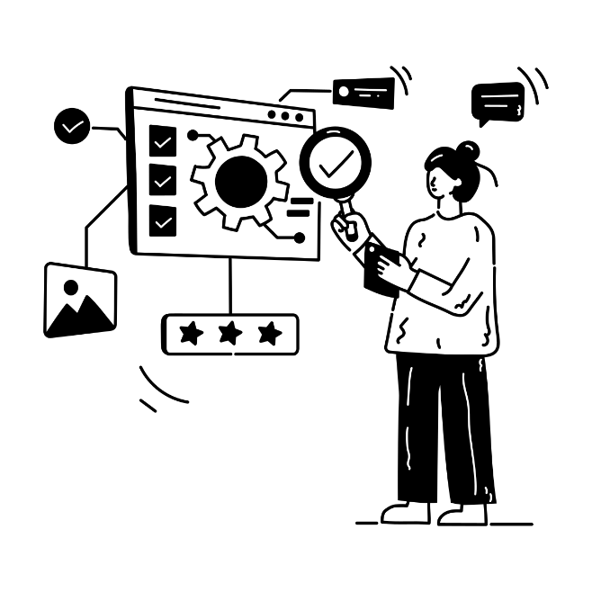

Having a methodical and formal approach to QA and accessibility will ensure that digital content receives the correct testing and validation for accessibility. This can help identify any barriers or challenges that may be encountered by readers and ensure that these are dealt with prior to publication.

Related Resources

* DAISY Webinar: [Accessibility Testing](https://daisy.org/news-events/articles/accessibility-testing-t-304-w/)
* [DAISY Toolbox Suite of Tools and Solutions](https://inclusivepublishing.org/toolbox/)

# Reflowable Content

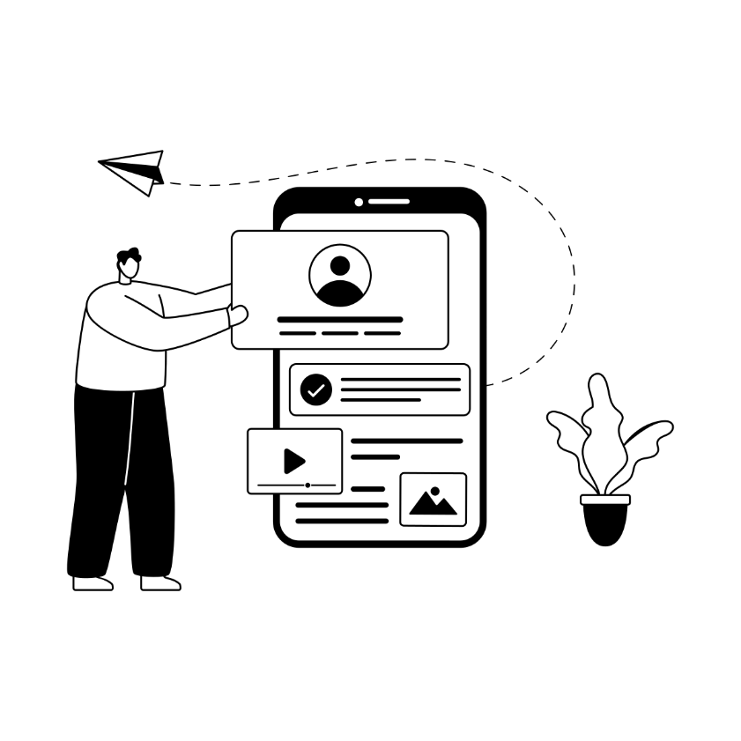

Being able to customize content according to an individual’s accessibility requirements is made possible with reflowable content which offers the greatest opportunity for accessibility in digital publications. Offering flexibility across various different screen sizes and display options, ensures the best reading experience and opportunities for essential accessibility requirements.

Related Resources

* [Accessible Publishing Knowledge Base: Reflow](https://kb.daisy.org/publishing/docs/css/reflow.html)

STEM

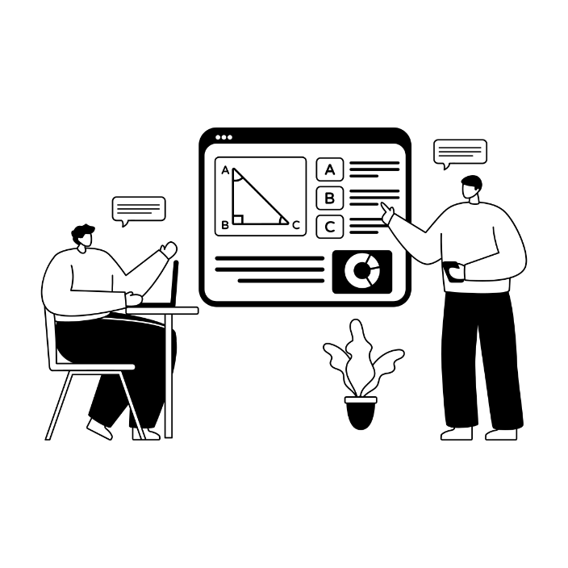

Science, technical, engineering and math content can be challenging for publishers and there is much ongoing work to create best practice for the presentation of this material. Access to complex material is key to ensuring equal depth of learning, irrespective of disability. Preserving complex content in a technical form, such as MathML, is key to providing access.

Related Resource

* DAISY Webinar: [Accessible Math and Science](https://inclusivepublishing.org/blog/accessible-math-and-science-in-digital-publications-t-94-w/)
* [Rich and Complex Content](https://inclusivepublishing.org/publisher/rich-and-complex-content/)

# Text To Speech

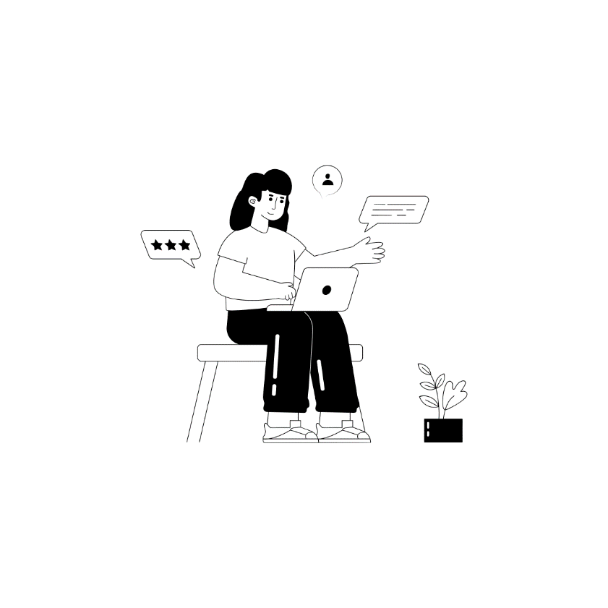

Text to speech technology converts information shown on screen into spoken words providing users with a read aloud option when accessing and navigating digital content. This feature is built into many reading systems and operating systems as standard, helping to support users with print disabilities with their access requirements.

Related Resources

* DAISY Webinar: [Accessibility in Practice](https://inclusivepublishing.org/blog/accessibility-in-practice-t-206-w/)
* [Accessible Publishing Knowledge base: Text to Speech Overview](https://kb.daisy.org/publishing/docs/text-to-speech/overview.html)

# User Experience

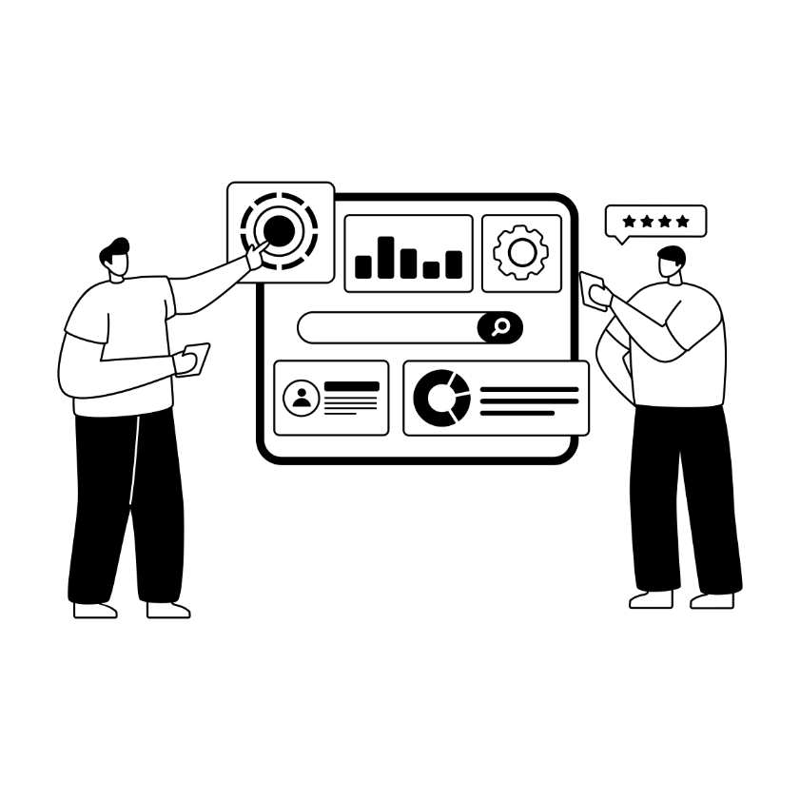

Consideration of the user experience throughout the publishing process can hugely benefit the end product. Testing with readers who have lived experience throughout production will enable everyone to appreciate and fully understand the needs of users. A fully accessible user experience requires all parties, from discovery to consumption, to have considered the user experience of people with disabilities.

Related resources

* [Building Inclusive Reading Experiences](https://inclusivepublishing.org/blog/building-inclusive-reading-experiences/)
* [Reading Systems Round Up](https://inclusivepublishing.org/blog/building-inclusive-reading-experiences/)

# Validate

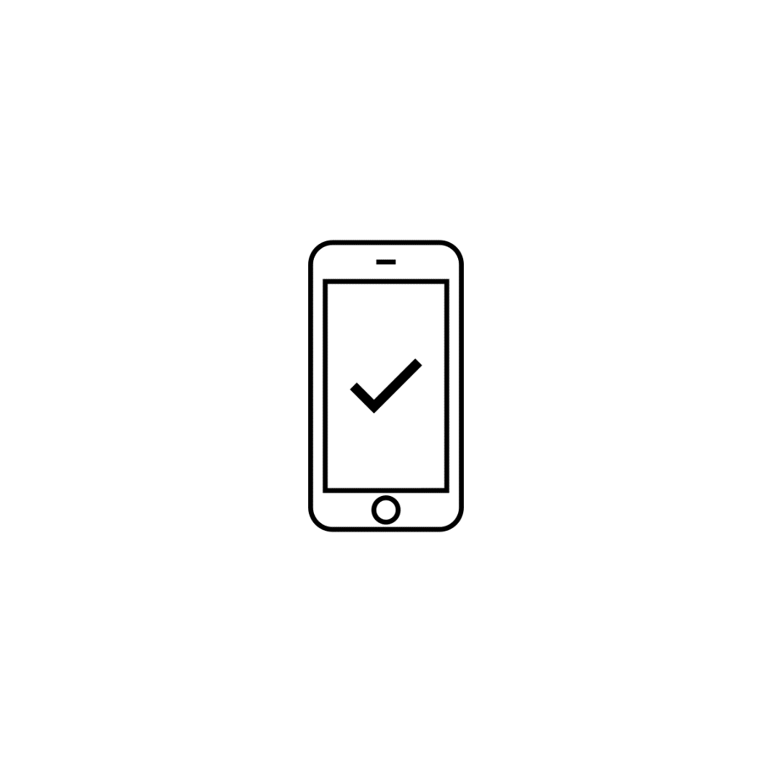

It is important to validate all content prior to publication to ensure that it conforms to the appropriate specification. This will provide a strong foundation for an accessible user experience by ensuring content can be opened on reading systems that comply with the specification for that specific format.

Related resources

* [EPUBCheck](https://www.w3.org/publishing/epubcheck/) has become an inherent part of the digital ebook workflow and ensures that EPUB content conforms to W3C specifications.
* [PDF UA Verification](https://helpx.adobe.com/uk/acrobat/using/create-verify-pdf-accessibility.html)
* [DAISY Toolbox](https://inclusivepublishing.org/toolbox/)

# WCAG

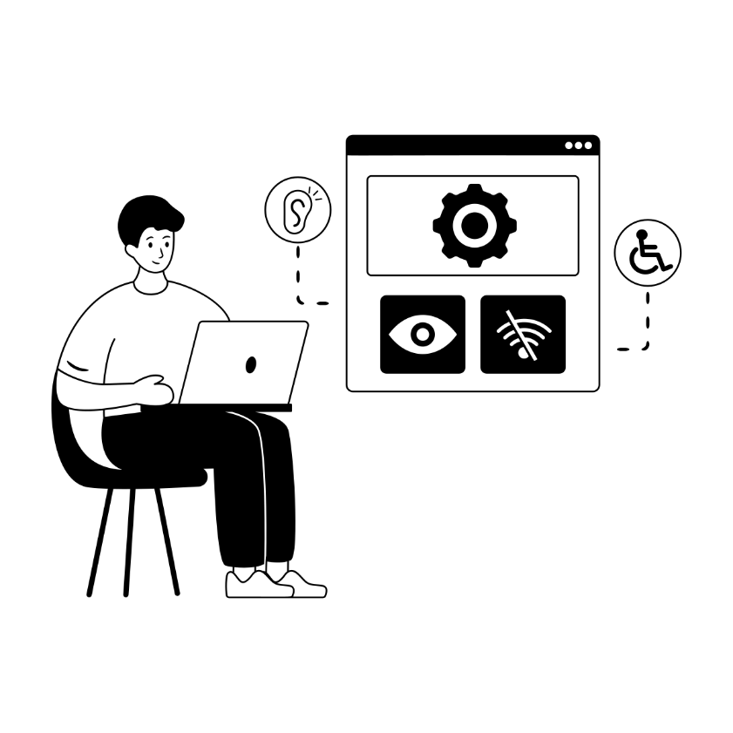

The Web Content Accessibility Guidelines (WCAG) are a set of industry standard technical documents that define and test against digital accessibility requirements for a diverse variety of users. The documents are organized under the 4 “POUR” principles: that content should be perceivable, operable, understandable and robust. WCAG has found application well beyond conventional web content, covering a broad range of digital content including ebooks.

Related resources

* [WCAG 2.2 for Publishing](https://inclusivepublishing.org/blog/introducing-wcag-2-2/)
* [WCAG 2 Overview](https://www.w3.org/WAI/standards-guidelines/wcag/)

# EXamine

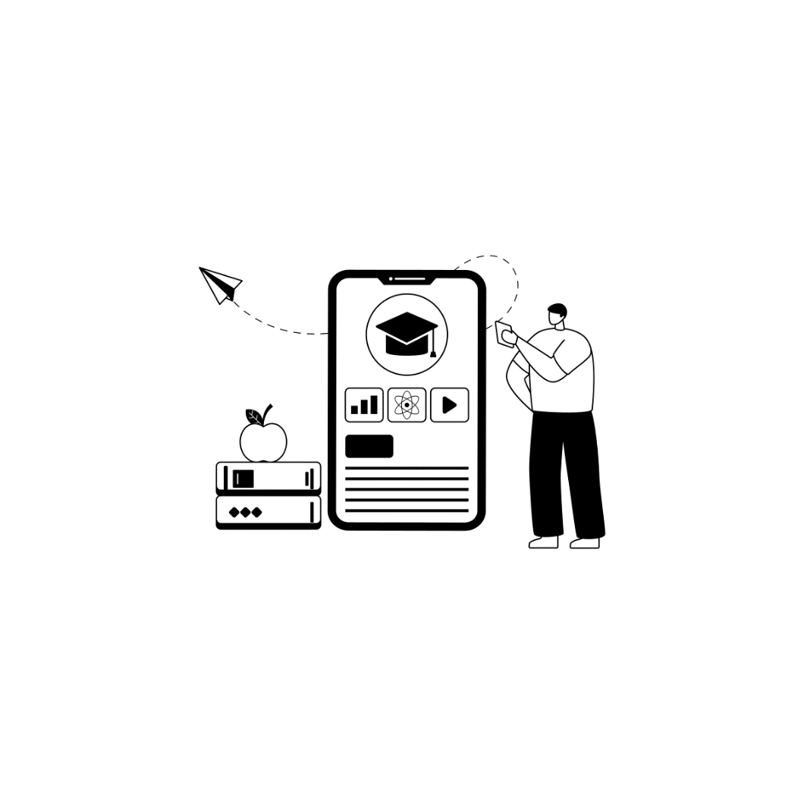

Constant examination and testing of digital content will ensure that current accessibility standards and best practice guidance are being adhered to. Running automated and manual tests such as Ace and SMART, and asking for feedback from users with lived experience are some of the best ways to examine the accessibility of your digital content

Related resources

* DAISY Webinar: [Accessibility Testing](https://inclusivepublishing.org/blog/accessibility-testing-t-304-days-w/)
* [DAISY Toolbox](https://inclusivepublishing.org/toolbox/)

# Your Accessibility Journey



It’s important to remember that accessibility is a journey not a destination. As new technologies evolve so do the associated standards and best practices. It might sound daunting, but the DAISY team are here to support you on your journey irrespective of your starting point. Most of our tools and information are freely available with the simple goal of helping you produce accessible content. If you’d like to support our work or are seeking bespoke advice we’re happy to talk.

Related resources

* [Lessons Learned in the Journey to Accessible Publishing](https://daisy.org/news-events/articles/lessons-learned-w/)
* The [Inclusive Publishing Partner](https://inclusivepublishing.org/inclusive-publishing-partner/) Initiative
* [Supporting the Work of the DAISY Consortium](https://inclusivepublishing.org/sponsorship/)

# Z39.86

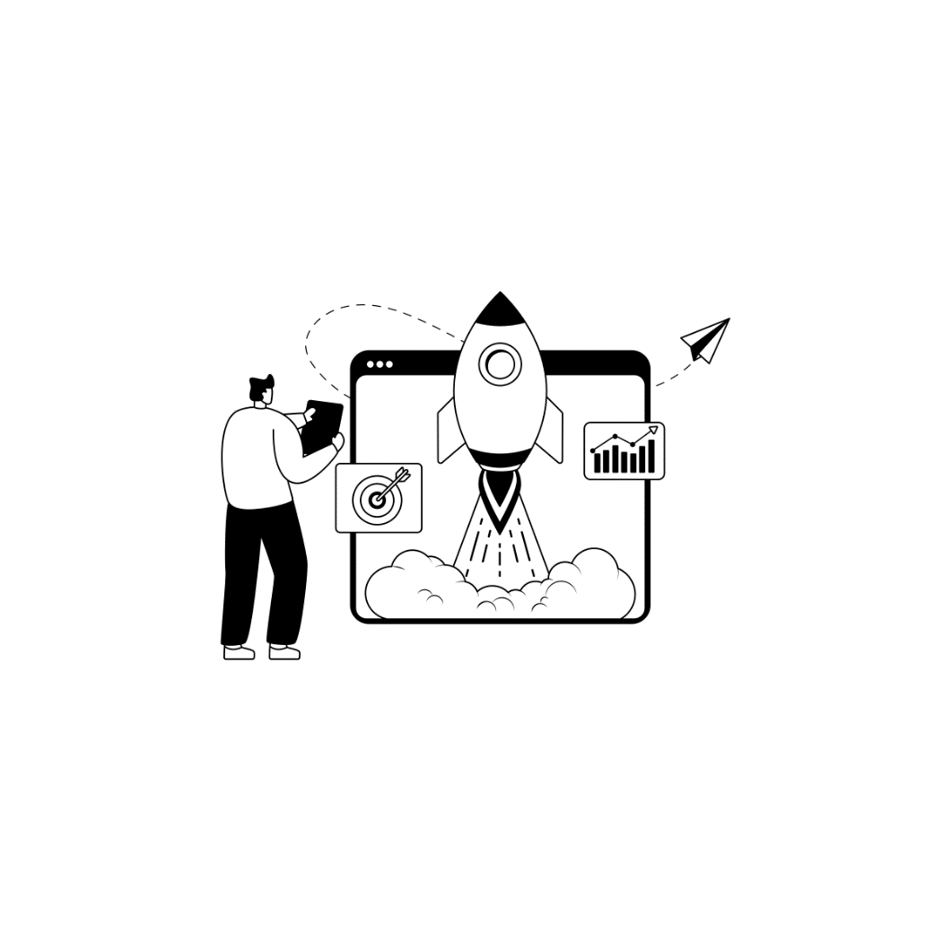

The Z39.86 DAISY standard for digital talking books is used globally by specialist libraries and was one of series of accessibility innovations that inspired modern digital publishing. The EPUB3 format, which was designed to be accessible from the very start, drew on many years of experience from specialist accessible publishing which defined the format and content of digital talking books.

Related resources

* [DAISY Z39-86 specification for digital talking books](https://daisy.org/activities/standards/daisy/daisy-3/z39-86-2005-r2012-specifications-for-the-digital-talking-book/)
* [History of the DAISY Consortium](https://daisy.org/about-us/history/)

# Credits

This book was produced by [The DAISY Consortium](https://daisy.org/) on the occasion of GAAD 2025. It was produced in MS Word and converted to EPUB 3 using the DAISY [WordToEPUB](https://daisy.org/activities/software/wordtoepub/) tool.

For further information about all of the topics listed in this book, visit <https://daisy.org/> and <https://inclusivepublishing.org/>

The DAISY Consortium welcomes your input on all the accessibility [tools and solutions](https://inclusivepublishing.org/toolbox/) that they have developed. [Your support](https://inclusivepublishing.org/sponsorship/) is vital for their ongoing maintenance and development.

The images used in this book were sourced under license from [The Noun Project.](https://thenounproject.com/)